TEA Input Template Guide
Step by step instructions with populated MEA and solar PV examples for the TEA Input Templates.

Purpose
Use this guide to complete Annex C for AEDO’s independent screening techno-economic assessment. Provide the evidence, projections and uncertainties that describe your technology. AEDO may harmonise boundaries, scale and common assumptions for comparison; the templates do not require you to produce AEDO’s complete TEA.
This guide uses their exact worksheet names and entry locations. Separate populated copies accompany this guide for training.
Current TRL | Final workbook | Example in this guide
1, 2 or 3 | AEDO TEA Input Template for TRL 1to3.xlsx | Example A — analytical novel absorber concept at current TRL 2
4, 5 or 6 | AEDO TEA Input Template for TRL 4to6.xlsx | Example B — hypothetical current TRL 5 project, with full-scale screening projections

Select by CURRENT TRL, not the proposed end-of-project TRL. A project at TRL 3 aiming for TRL 4 uses the TRL 1–3 workbook. The workbooks are alternatives; applicants do not routinely complete both.

How the examples should be used
MEA capture is an established process. The examples concern a hypothetical novel absorber arrangement within an MEA system. Their TRL labels are scenario premises, not assessments of conventional MEA or claims that physical evidence exists. All project quantities and costs are illustrative. The examples contain no experimental results, run histories, supplier quotations or actual project records.
Example A demonstrates an early-stage entry with an absorber-only boundary. Example B demonstrates a projected integrated capture island and explicitly records missing demonstrated evidence. It illustrates how to document assumptions and evidence gaps; demonstrated TRL 5 evidence is required for an actual submission.
Where to go | Content
Sections 2 and 3 | Start-up instructions, obligations and nuanced interpretation
Section 4.1 | Template A worked example, in worksheet order
Section 4.2 | Template B worked example, in worksheet order
Section 5 | Non-process mapping and solar PV example
Section 6 | Submission checks, dropdowns, references and revision summary

Contents
Select an entry to go directly to that section. Appendix links return to the corresponding worked example.
1. Purpose 1
2. Before completing the workbooks 2
3. Worksheet workflow and requirement nuances 3
4. Populated examples for process projects 4
4.1. MEA Worked Example TRL 1to3 5
4.2. MEA Worked Example TRL 4to6 13
5. Applying the templates to non process projects 29
5.1. Solar PV Worked Example for TRL 4–6 30
6. Checks and common errors before submission 42
Appendix A — MEA Worked Example for TRL 1–3 43
Appendix B — MEA Worked Example for TRL 4–6 44
Appendix C — Solar PV Worked Example for TRL 4–6 45

Before completing the workbooks
Prepare the application package
Use Annex C with the main proposal and its supporting evidence. Prepare the technology boundary, diagram, current evidence, justified deployment targets, relevant flows, energy requirements and uncertainties. For Template B also gather available economic assumptions and cost sources. Reference the proposal section, table, figure or supporting file precisely instead of repeating a complete current-scale dataset.
Enter information in the right place
Yellow marks an applicant entry area, subject to the section’s requirements. Colour alone does not establish mandatory status or protection. Replace pre-filled example prompts with project-specific information. Keep formulas intact and check print preview after inserting diagrams or adding rows.
Issue | Operational instruction
Scale | Label demonstrated/current information separately from Full-scale projected/target information. In Source / Reference explain capacity, time basis, evidence and extrapolation.
Numbers | Enter typed numbers in numeric cells. Put the unit in Unit, and put a range, estimate basis or confidence in the associated reference/notes field. Do not enter “~” as a numeric value.
Unknown value | Leave the numeric cell blank. In the adjacent reference/notes field state “Not available at current TRL”, why it is unknown and a linked data-gap ID. Unknown is not zero.
Inapplicable property | Explain “Not applicable” and the reason. It means the property is irrelevant, rather than unknown. These phrases are explanatory text, not new dropdown options.
Projection | Use the closest existing evidence option and explain assumptions. A modelled target does not become a measured result because it is expressed numerically.
Test history | Enter actual counts, durations and dates for demonstrated claims. For theoretical/projected claims use Not applicable with a reason. Where test records are unavailable, record the evidence gap.
Batch or cyclic operation | State per-cycle quantities or cycle averages, cycles per hour/year and annualisation. Do not mix transient peaks with average throughput.

Boundary and outcome
Define the technology/proposal boundary, including exclusions and dependencies. A reactor, device, subsystem or integrated process may be appropriate. AEDO’s eventual comparison boundary may be broader. Capture is a physical separation outcome; avoided emissions require a defined counterfactual and the additional emissions associated with the chosen boundary. Captured CO₂ is not automatically permanently stored or avoided.

Worksheet workflow and requirement nuances
Worksheet | Template A - AEDO TEA Input Template for TRL 1to3.xlsx | Template B - AEDO TEA Input Template for TRL 4to6.xlsx
0-Cover | Project Title, Authorised Signatory Name, Date and declaration | Same cover inputs; identify projections and their scales
1-Diagram | Typically 3–5 blocks; brief descriptions; stream IDs optional | Diagram with numbered streams matching 2-StreamTable; engineering detail follows evidence
2-StreamsEnergy / 2-StreamTable | Boundary streams as rows; no T/P/composition requirement; energy intensity addressed | Boundary and internal streams as columns; relevant phase/T/P/components and energy rows
3-Claims | At least one primary claim plus justified full-scale cost/performance targets | Current claims and full-scale targets; applicable history; safety/operability/scale-up fields
4-Balance |  | At TRL 4 relevant mass/carbon encouraged; energy mandatory. At TRL 5–6 applicable balances mandatory
5-Assumptions |  | Minimum 8 entries; cover stream and cost parameters, with shared basis allowed for named groups
6-Costs |  | Detailed costs optional at TRL 4, expected at TRL 5–6
4-DataGaps / 7-DataGaps | Minimum 3 genuine gaps | Minimum 3 genuine gaps, linked to 5-Assumptions where possible

Populated examples for process projects
Open the example workbook alongside this guide, and enter your own information into a fresh blank template. The figures that follow are rendered directly from the delivered populated Excel files (see appendix). Yellow entry areas, native headers, dropdown indicators and worksheet coordinates are retained. Wide sections are split into readable excerpts; the entire completed record remains in the accompanying workbook.
For 2-StreamTable, some figures place native column A beside selected native input columns, omitting column B guidance and intervening streams. Captions identify both ranges. This changes the figure layout only; the workbook columns are unchanged. Read the guidance in column B when completing your own file.
Example file | Scope
MEA Example TRL 1to3.xlsx | MEA_A: current TRL 2 analytical absorber concept. Three blocks, five boundary entries, four claims and three gaps.
MEA Example TRL 4to6.xlsx | MEA_B: hypothetical current TRL 5 novel absorber project, with full-scale projections. Six blocks, 19 streams, 16 assumptions and six gaps.
Solar PV Example TRL 4to6.xlsx | SOLAR: hypothetical current TRL 4 novel lightweight module, projected to a 100 kWdc rooftop array. Three blocks, seven energy streams, ten assumptions and three gaps.

These are teaching files, not actual proposals or demonstrated TRL assessments. Prices, yields, duty estimates, uncertainties and carbon factors are illustrative inputs. No actual signatory, submission date, test run or supplier quotation is asserted. The cover date is left blank.

MEA Worked Example TRL 1to3
Step A1 Identify the analytical case
Use 0-Cover for Project Title, Authorised Signatory Name and Date. The example identifies itself as illustrative and leaves the actual submission date blank. Current TRL 2 describes the hypothetical novel contactor concept, not conventional MEA capture generally.
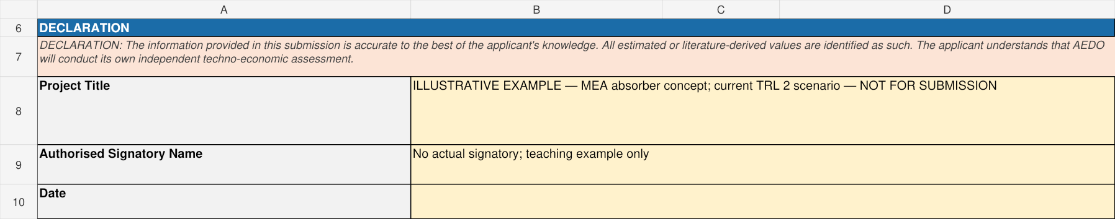
MEA_A | 0-Cover | A6:D10
ILL-A uses 0.1 kmol/h of dry gas with 12/84/4 mol% CO₂/N₂/O₂ and molecular weights 44/28/32 kg/kmol. Gas is 3.008 kg/h, of which 0.528 is CO₂. Ten kg/h of fresh CO₂-free 30 wt% MEA solution supplies 3 kg/h MEA and 7 kg/h water. Assumed 90% capture transfers 0.4752 kg/h CO₂. No experiment is represented.

Step A2 Draw the boundary
In 1-Diagram enter System Boundary Description at D4:G4 and insert the BFD into the A9:G27 area. The image shown is embedded in the example file. Keep labels legible and match block and stream names.
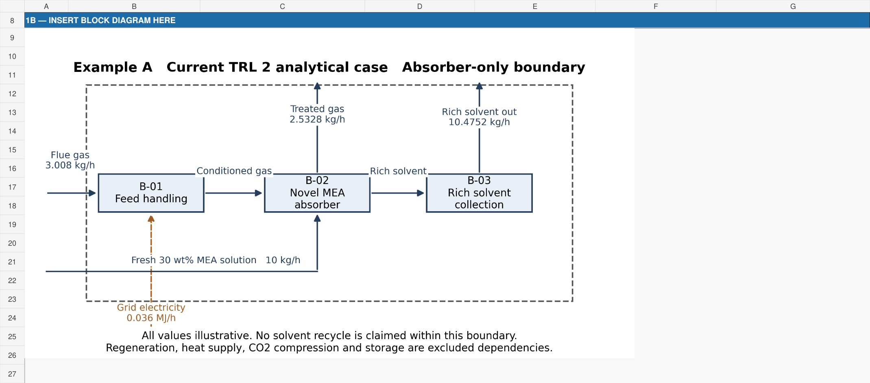
MEA_A | 1-Diagram | A8:G27
Regeneration, recycling, compression and storage are outside this absorber-only boundary. They have an unquantified burden; exclusion does not make their energy or cost zero.

Step A3 Describe the blocks
Enter rows 33–35 using the actual block table. Select Continuous from Mode of Operation. The two views complete the same three rows.
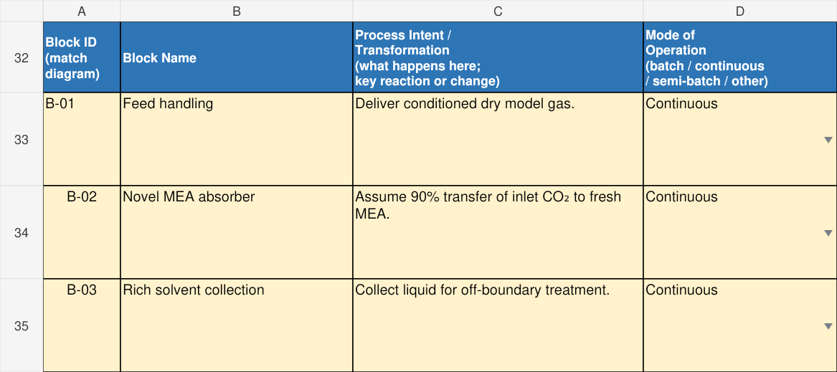
MEA_A | 1-Diagram | A32:D35
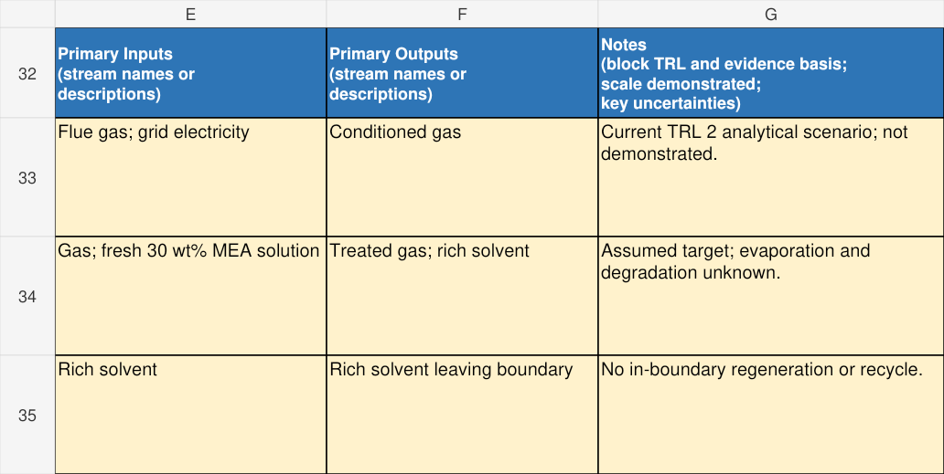
MEA_A | 1-Diagram | E32:G35

Step A4 Enter boundary streams
In 2-StreamsEnergy rows 9–13, enter names, the existing Type and Direction dropdown values, numeric Estimated Flow Rate and Unit. These are current analytical hourly quantities. Internal gas transfer is visible in the BFD and is not added again as a boundary input.
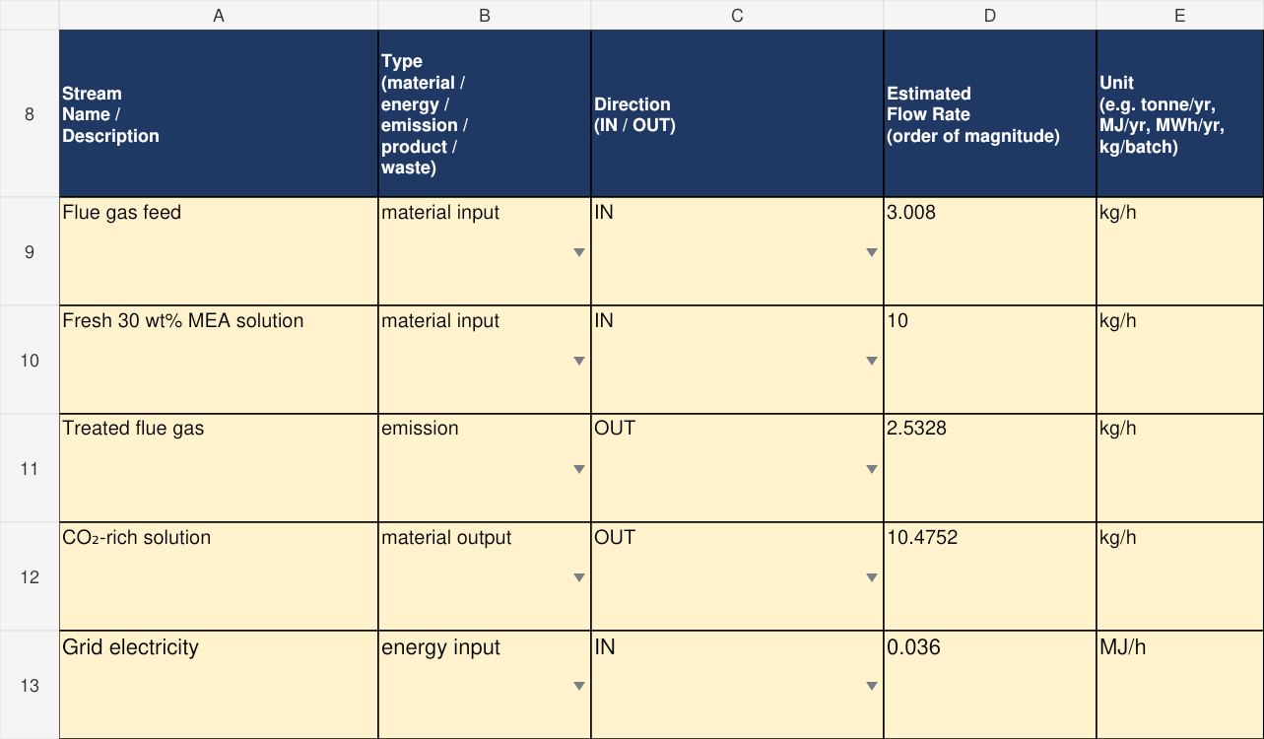
MEA_A | 2-StreamsEnergy | A8:E13
Inputs 3.008 + 10 = 13.008 kg/h; outputs 2.5328 + 10.4752 = 13.008 kg/h. The closure follows assumed capture and idealised losses. It does not validate the concept.

Step A5 Record the evidence basis
Complete F:I for the same stream rows. Select Applicant estimate — justified from the stream list; place the calculation in Source / Reference. Calculated is not an option in this particular list.
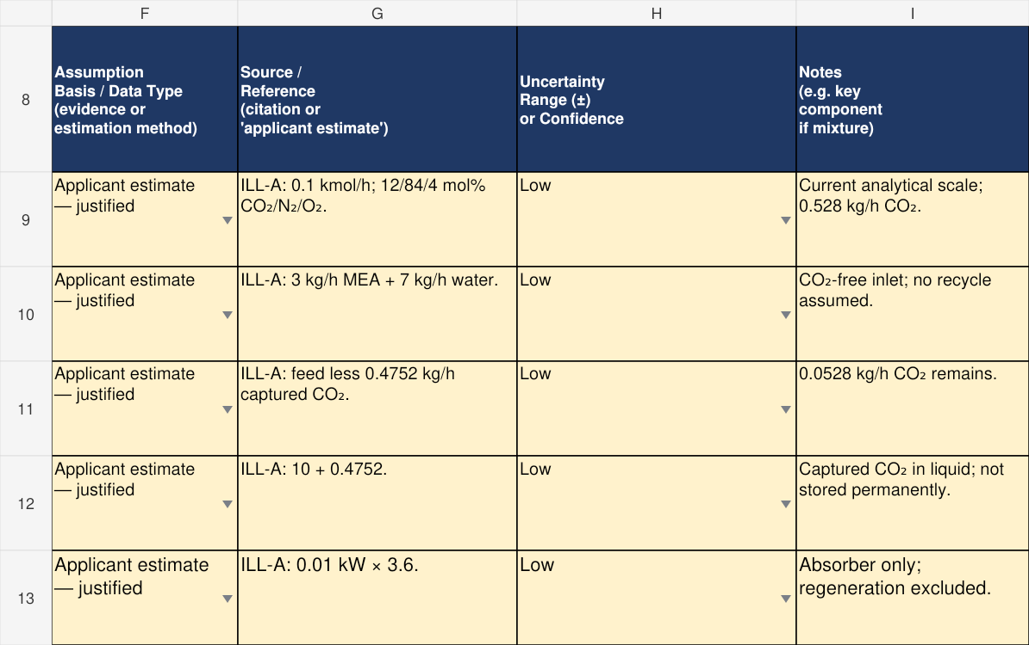
MEA_A | 2-StreamsEnergy | F8:I13
Unknown flow remains blank with a reason and linked gap. Enter zero only for a justified zero. Do not paste an assumed target into a measured-evidence category.

Step A6 Enter energy and intensity
In section 2B, one row describes the small fan and pump: 0.01 kW × 3.6 = 0.036 MJ/h. There is no in-boundary regeneration heat. The two views show the same row.
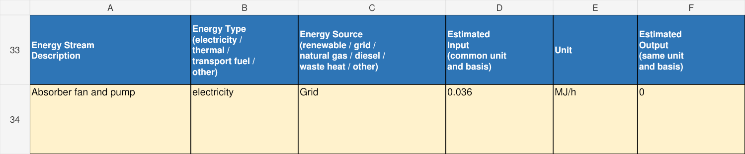
MEA_A | 2-StreamsEnergy | A33:F34
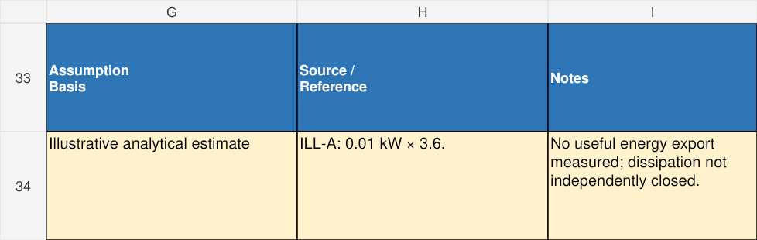
MEA_A | 2-StreamsEnergy | G33:I34
MEA_A | 2-StreamsEnergy | B44:F44
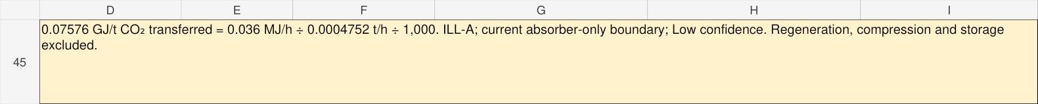
MEA_A | 2-StreamsEnergy | D45:I45
D44 and F44 retain their SUM formulas. Specific Energy Intensity is manual: 0.036 MJ/h ÷ 0.0004752 t/h = 75.7576 MJ/t = 0.0757576 GJ/t. Its absorber-only scope makes it unsuitable for direct comparison with an integrated regeneration duty.

Step A6 State current claims
Complete 3-Claims rows 8–9. The views show metric/value fields followed by evidence, scale and history. Current analytical targets are labelled as such; actual run counts and test dates have not been supplied.
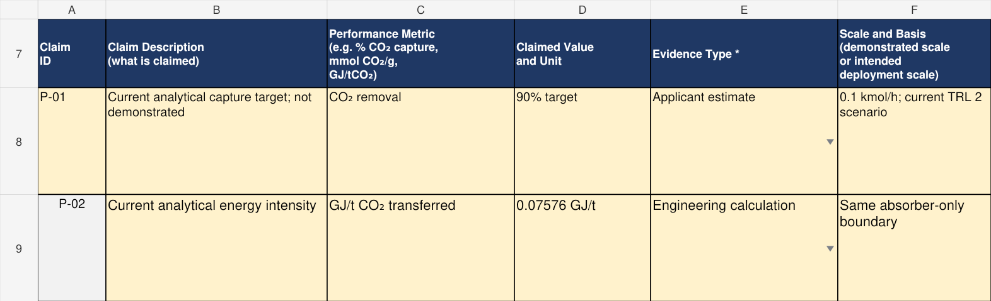
MEA_A | 3-Claims | A7:F9
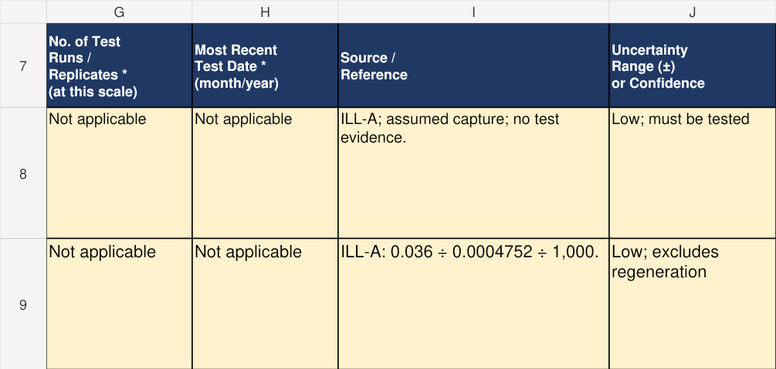
MEA_A | 3-Claims | G7:J9

Step A7 State deployment targets
Rows 10–11 give full-scale projected/target performance and cost. The intended 1,000 kmol/h throughput is 10,000 times the analytical case; constant capture is a target, not an established scale-up law. The 8 million SGD target covers the absorber/blower equipment package only.
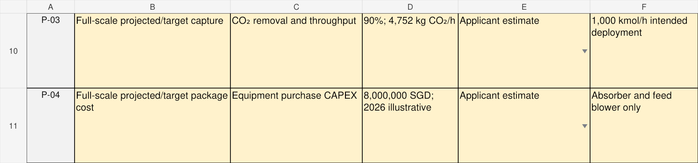
MEA_A | 3-Claims | A10:F11
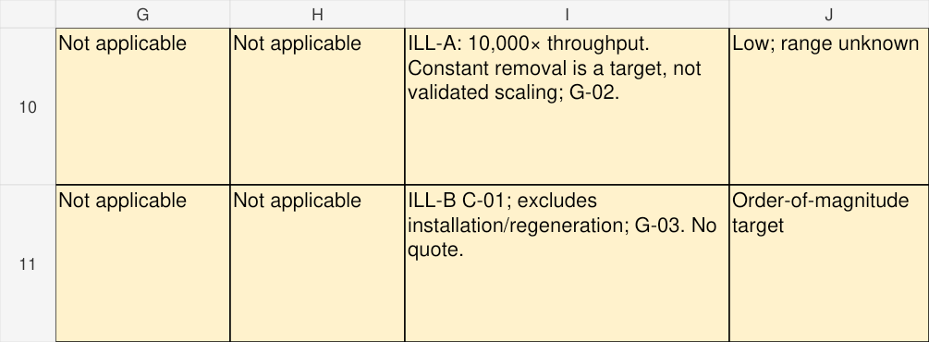
MEA_A | 3-Claims | G10:J11

Step A8 Record genuine data gaps
Complete 4-DataGaps with the unknown parameter, its importance, current estimate, next evidence activity and priority. The three actual records below cover solvent/regeneration losses, scale-up and package cost.
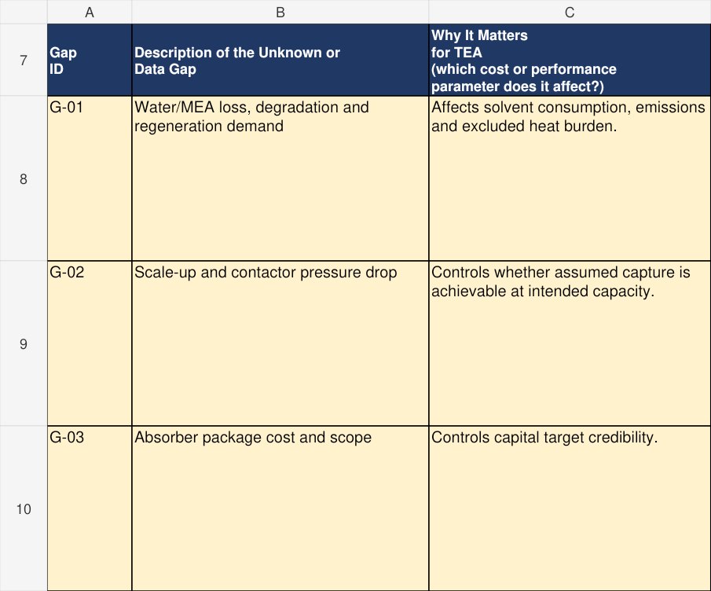
MEA_A | 4-DataGaps | A7:C10
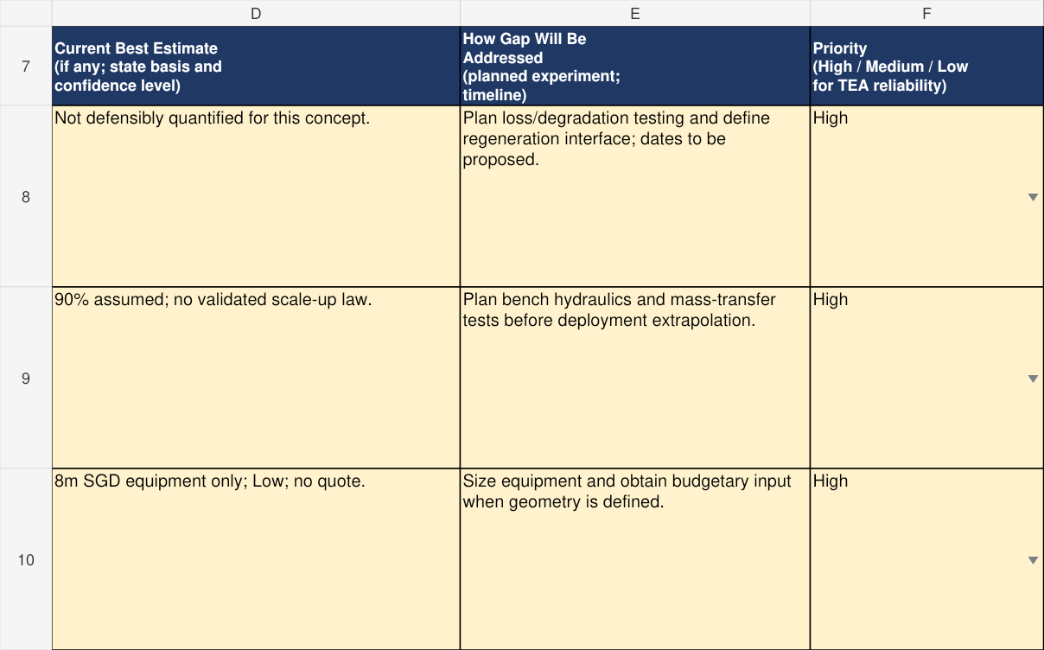
MEA_A | 4-DataGaps | D7:F10
Finish by reconciling the diagram, boundary flows, claims and exclusions. Template A has no separate 5-Assumptions or 6-Costs sheet.

MEA Worked Example TRL 4to6
Step B1 Set the full scale projection
Use the TRL 4–6 workbook for the hypothetical current TRL 5 project. The numerical dataset is a deployment projection, not pilot measurements. Real current evidence remains G-01.
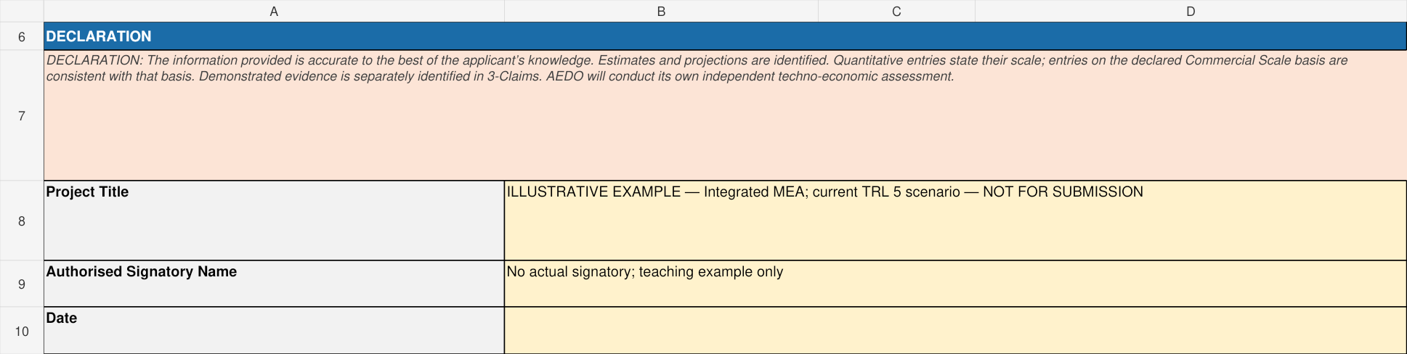
MEA_B | 0-Cover | A6:D10
ILL-B uses 1,000 kmol/h conditioned dry gas, 12/84/4 mol% CO₂/N₂/O₂, 90% capture and 8,000 h/yr. Captured CO₂ is 4.752 t/h × 8,000 = 38,016 t/yr. Capacity Factor is 91.3242%. The product is wet CO₂ at 40°C and 1.8 bar absolute; final drying and compression are excluded.

Step B1 Insert the process diagram
Enter System Boundary Description at D5:H5 of 1-Diagram and insert the numbered PFD into A9:H30. All 19 stream IDs have matching 2-StreamTable columns. S-18 is the energy carried by cooling-water return, not another material pipe.
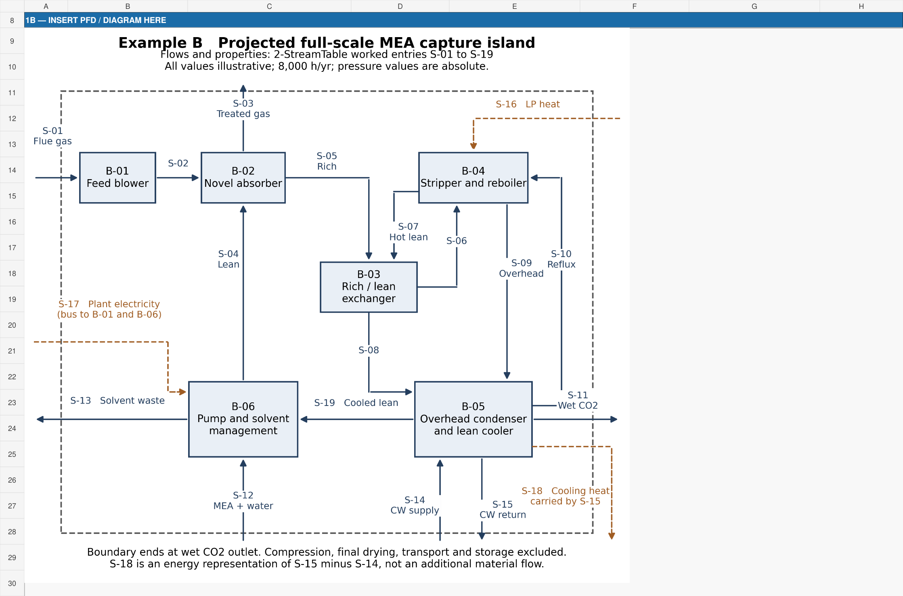
MEA_B | 1-Diagram | A8:H30

Step B2 Complete block descriptions
Rows 36–41 describe all six blocks. These native views show the first three. Complete the remaining blocks in the same table, without changing the existing columns. Block TRL dropdowns remain blank because no block-level evidence is supplied; C36 explains the gap.
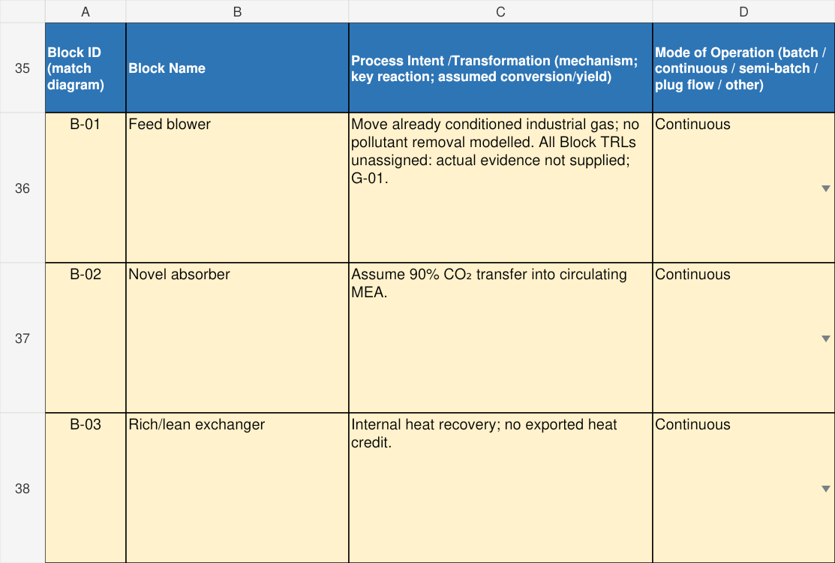
MEA_B | 1-Diagram | A35:D38
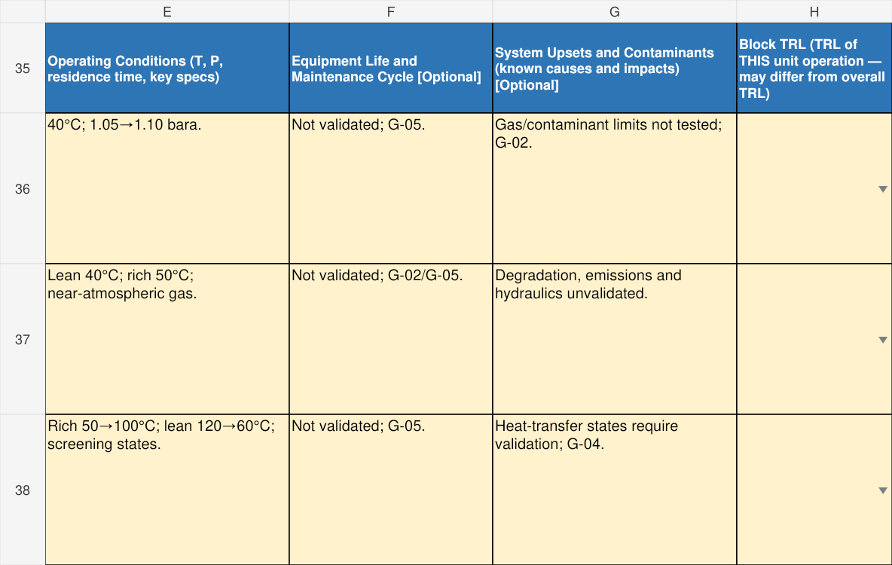
MEA_B | 1-Diagram | E35:H38
Columns F/G are optional. An assumed project lifetime is not tested equipment life. State uncertainty and link the relevant gap.

Step B3 Enter stream properties
2-StreamTable is a matrix: properties in rows, individual streams in columns C:U. These views show A6:A14 beside C6:E14 for the first three streams. All material flows are kg/h; pressure is explicitly absolute in this example.
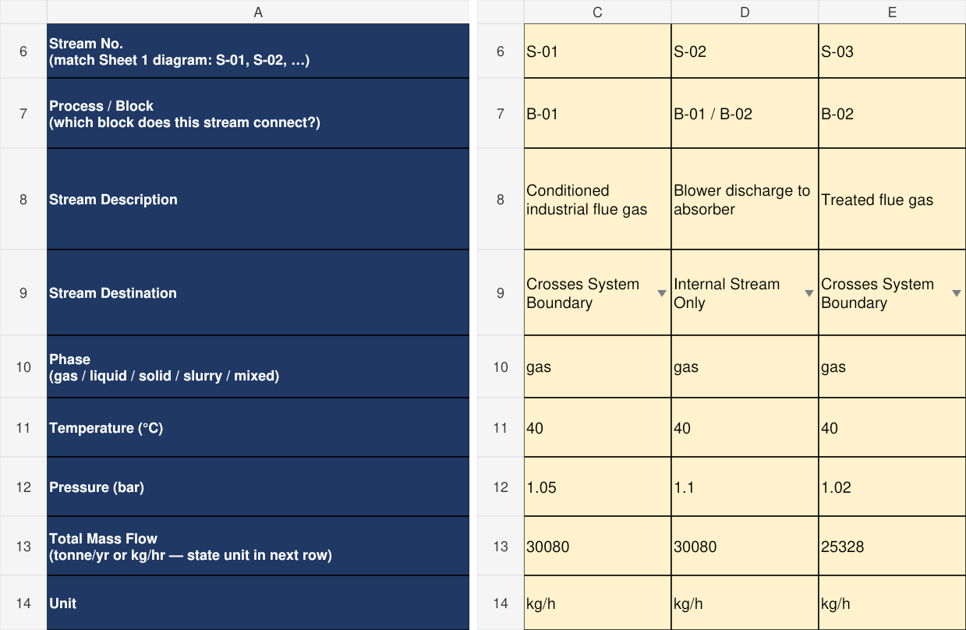
MEA_B | 2-StreamTable | A6:A14 plus C6:E14
Use Stream Destination to distinguish Crosses System Boundary from Internal Stream Only. There is no separate Direction row here; explain direction in the description/reference. Do not total the internal recirculation as fresh boundary demand.

Step B4 Explain sources and components
Use the exact Assumption Basis / Data type dropdown at row 15 and Source / Reference at row 16. Customise permitted component labels to O₂ and MEA for this case. The lower view shows three internal solvent-stream columns.
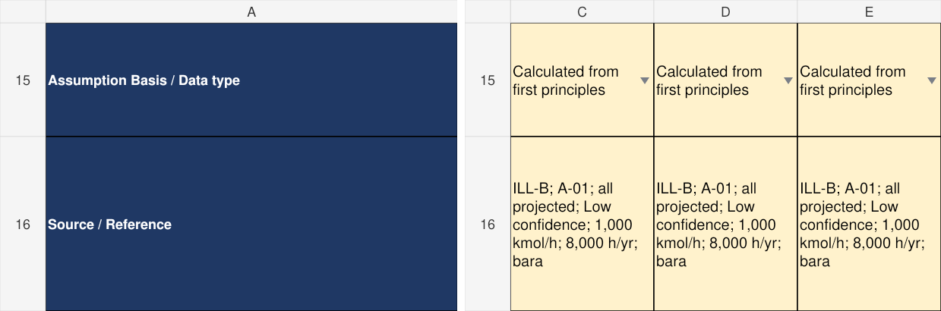
MEA_B | 2-StreamTable | A15:A16 plus C15:E16
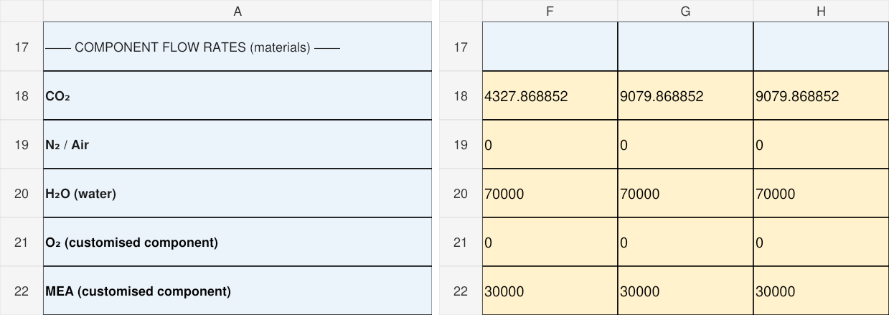
MEA_B | 2-StreamTable | A17:A22 plus F17:H22
The CO₂-free carrier is 30,000 kg/h MEA plus 70,000 kg/h water. Lean loading is 0.2 mol CO₂/mol MEA, and captured CO₂ raises rich loading to about 0.4196. Loaded-solution mass fraction differs from the 30 wt% carrier basis.

Step B5 Enter energy streams
Native A27:A31 is placed beside R27:T31, corresponding to heat input, electricity and cooling output. Material flow is left blank for pure energy streams. The wet CO₂ product also carries water-vapor enthalpy in M31.
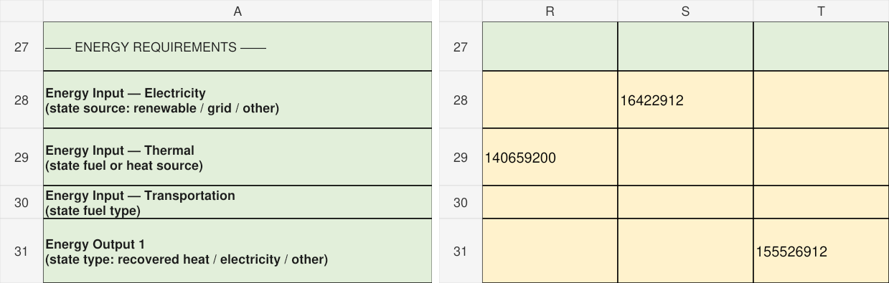
MEA_B | 2-StreamTable | A27:A31 plus R27:T31
Heat = 3.7 GJ/t × 38,016 t/yr = 140,659,200 MJ/yr. Electricity = 0.12 MWh/t × 38,016 × 3,600 = 16,422,912 MJ/yr. Product vapor enthalpy is 1,555,200 MJ/yr; remaining cooling output is 155,526,912 MJ/yr. Cooling is derived by difference, not an independently validated enthalpy balance.

Step B6 Separate projections from evidence
Complete 3-Claims. These excerpts show the first two projected claims. Rows 8–9 additionally record CAPEX and included cash OPEX; row 10 explicitly records missing demonstrated/current performance. A projection does not supply a test record.
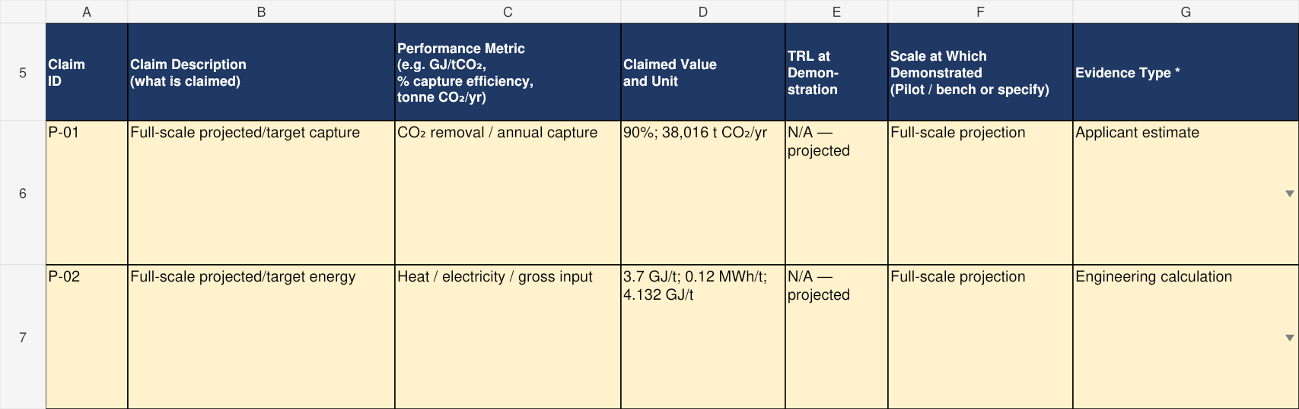
MEA_B | 3-Claims | A5:G7
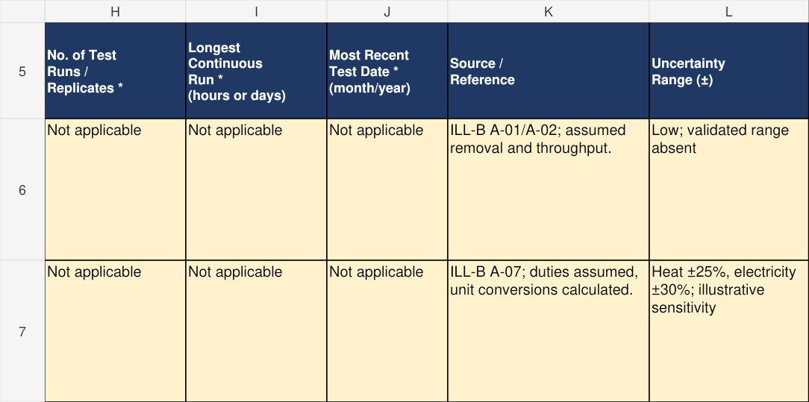
MEA_B | 3-Claims | H5:L7
For a real demonstrated claim, supply actual scale, TRL at Demonstration, Evidence Type, run count, longest run, most recent test month/year and a precise source. Select Modelling — validated against data only when validation exists.

Step B7 Explain operating constraints
In 3-Claims H29:L33 address Known Hazardous Materials / Conditions, Key Scale-Up Bottlenecks, Capacity Factor Basis and Justification, Equipment Life and Maintenance Cycle, and Mode of Operation and Implications. The workbook example contains the complete responses.
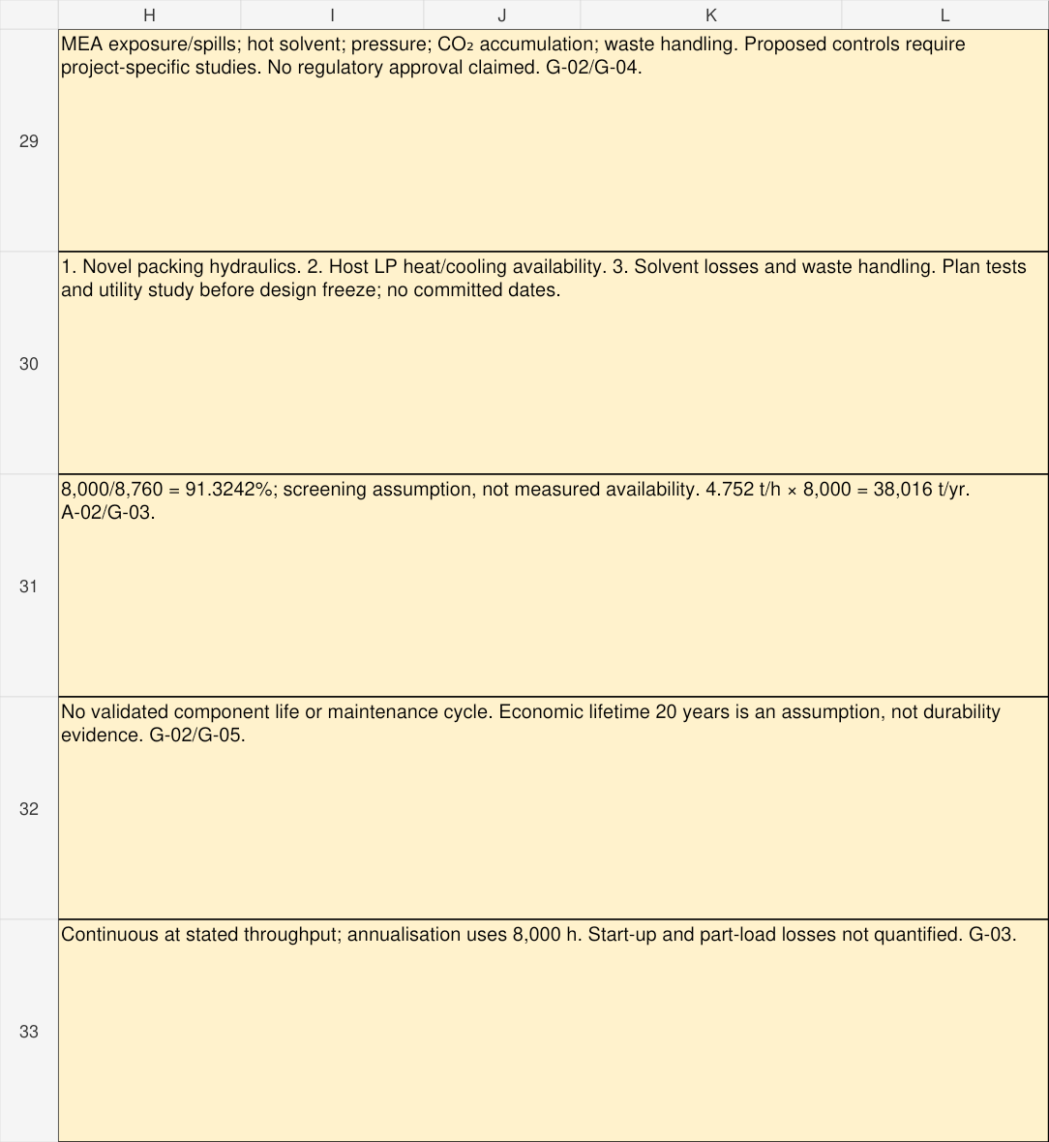
MEA_B | 3-Claims | H29:L33
The three proposed bottlenecks are hydraulics/scale-up, host utility availability and solvent loss/emissions/waste management. The economic 20-year lifetime is not a demonstrated durability result. No approval or formal hazard assessment is implied.

Step B8 Reconcile material and carbon
In 4-Balance use boundary streams only, annualised to tonne/yr. Split mixed streams into disjoint constituent rows so the dry constituent carbon fraction multiplies that constituent mass. The views show inputs and their carbon amounts.
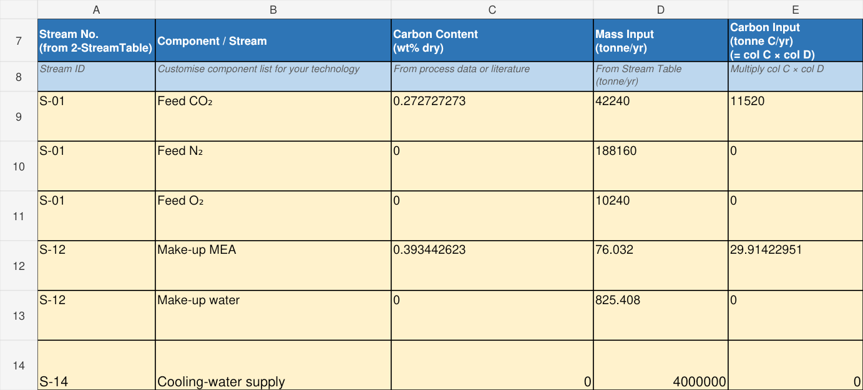
MEA_B | 4-Balance | A7:E14
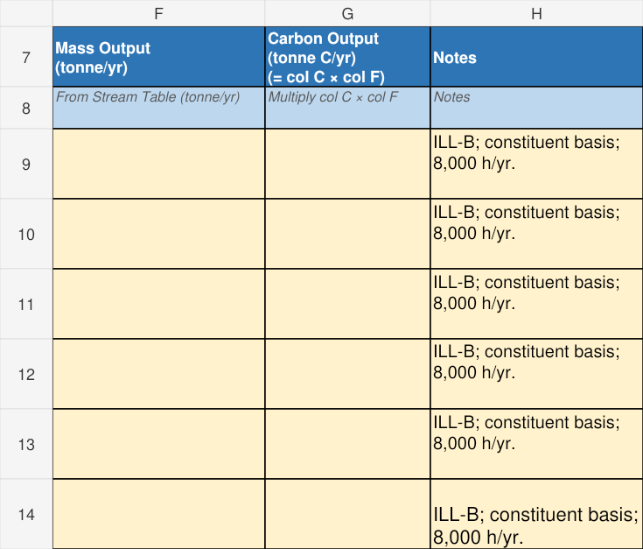
MEA_B | 4-Balance | F7:H14
Carbon flows are manual. CO₂ carbon fraction is 12/44 and MEA carbon fraction 24/61. Include solvent carbon; do not multiply a dry fraction by total wet-stream mass. In these example cells, enter C as a decimal mass fraction: 0.272727 represents 27.2727 wt%. Use the same fraction in the manual carbon-flow calculation; do not multiply the mass by 27.2727.

Step B9 Check outputs and closure
The output rows separately include product CO₂ and product water, treated gas, purge components and cooling-water return. Internal solvent recycles are excluded.
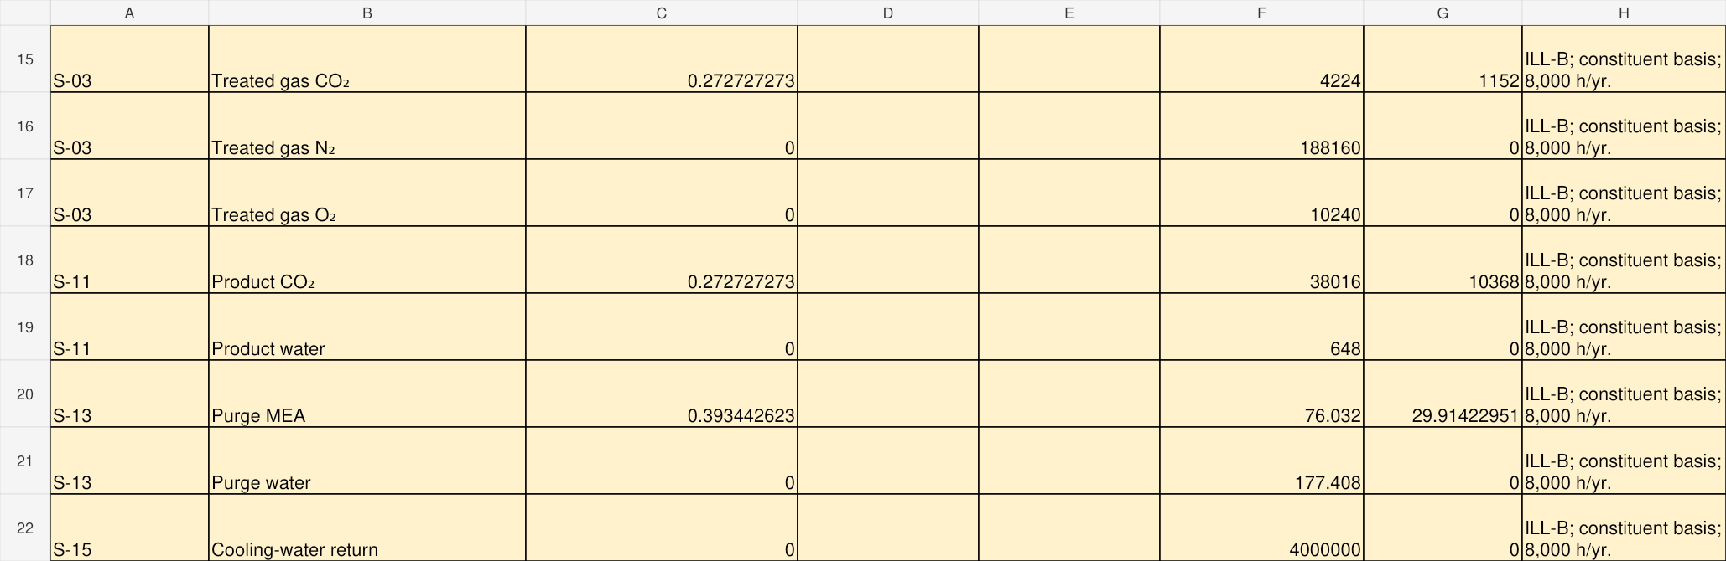
MEA_B | 4-Balance | A15:H22
MEA_B | 4-Balance | A28:G30
Mass input and output both equal 4,241,541.44 t/yr, including 4,000,000 t/yr cooling water. Carbon input/output both equal about 11,549.91423 t C/yr. The inherited closure formulas remain intact. A mathematical closure under assumptions is not proof of measured accuracy.

Step B10 Reconcile energy
In 4-Balance section 4B enter annual MJ values using the same boundary. The two views show the input/output rows and their reference notes. Do not credit internal rich/lean heat recovery twice.
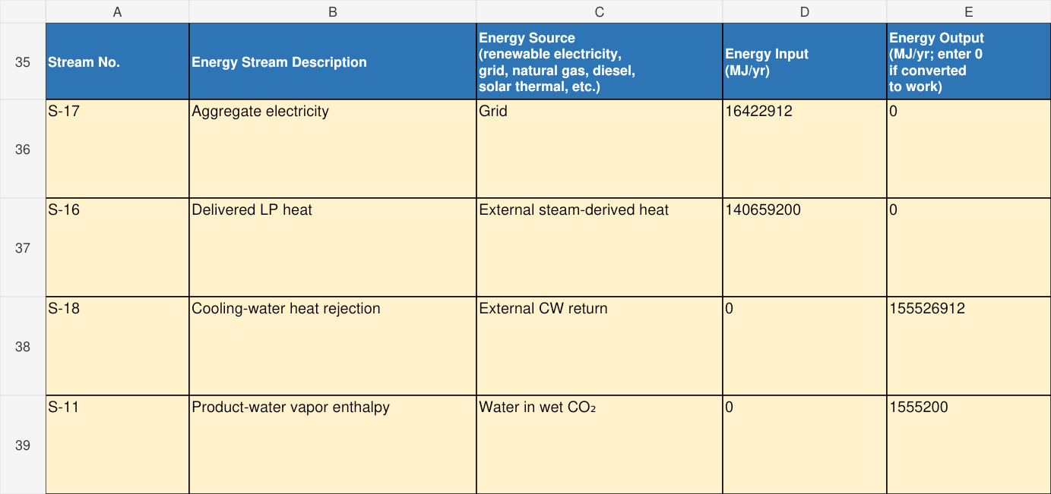
MEA_B | 4-Balance | A35:E39
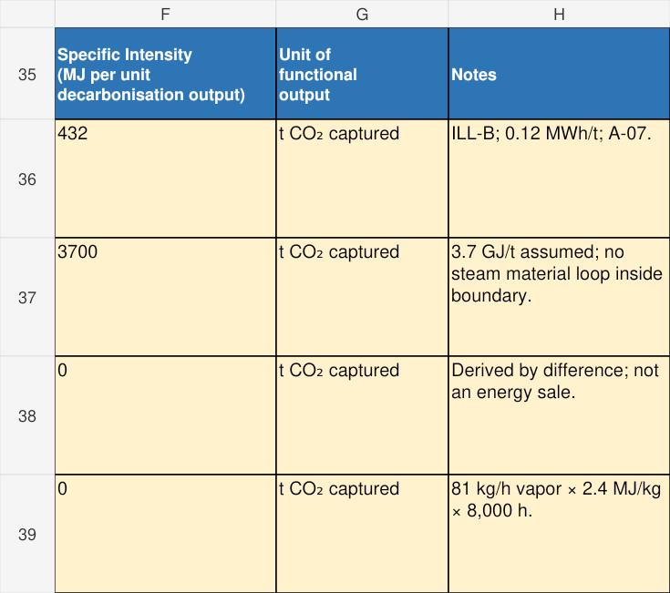
MEA_B | 4-Balance | F35:H39
MEA_B | 4-Balance | B50:E50
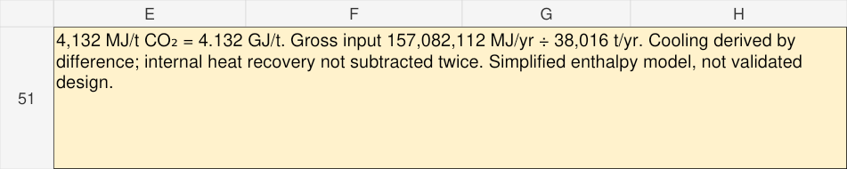
MEA_B | 4-Balance | E51:H51
Total energy input and output are 157,082,112 MJ/yr. Manual intensity is 157,082,112 ÷ 38,016 = 4,132 MJ/t = 4.132 GJ/t captured. This combines heat and electricity as energy, without an exergy or primary-energy weighting.

Step B11 Register assumptions
5-Assumptions contains 16 actual records. These excerpts show the first four records and their companion columns. Link uncertain values to 7-DataGaps and use the exact dropdown choices. A justified common basis may cover named groups of parameters.
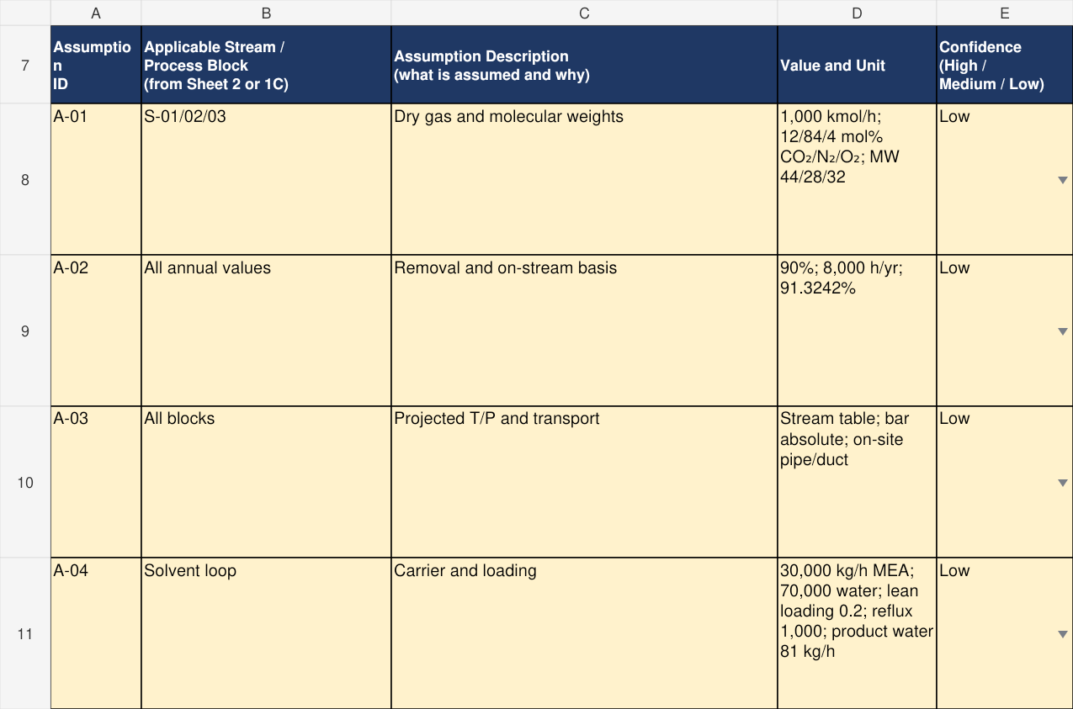
MEA_B | 5-Assumptions | A7:E11
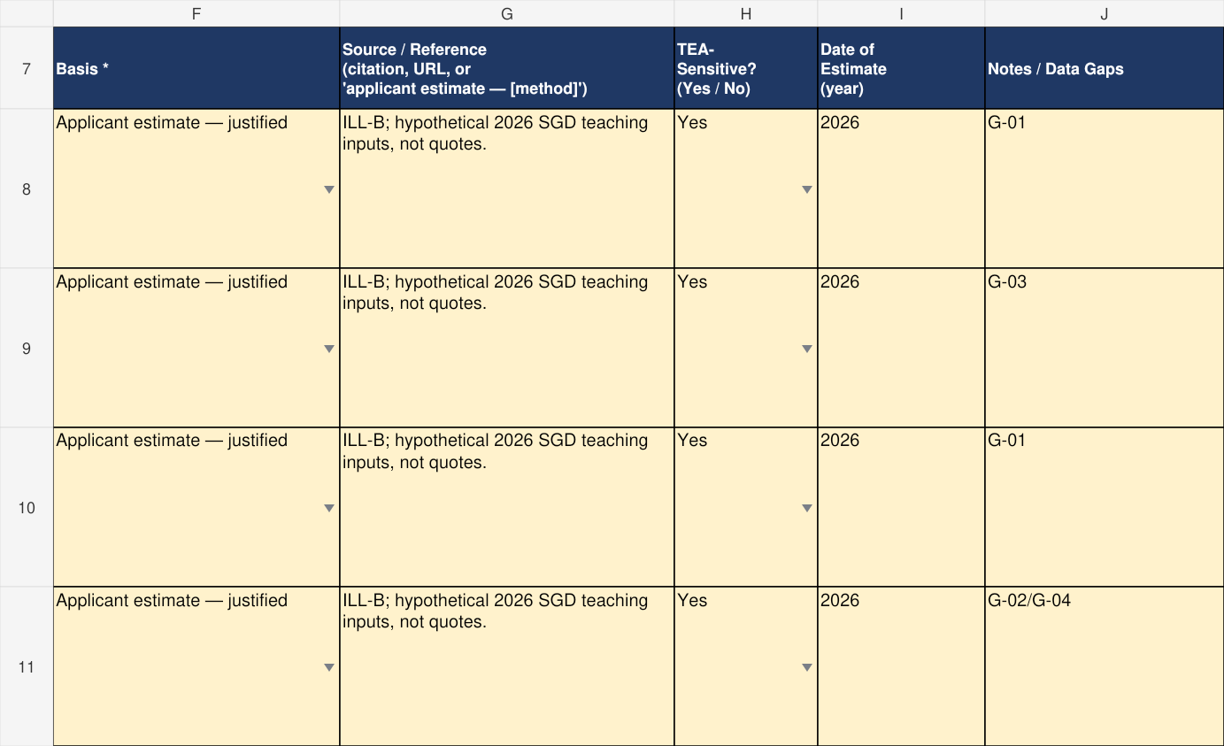
MEA_B | 5-Assumptions | F7:J11
The illustrative year 2026 is an assumed cost/reference year, not a source-publication date. Replace it with the appropriate project reference year and actual source.

Step B12 Enter economic assumptions
In 6-Costs B7:B11 enter the capacity, Cost Year, Currency, Project Lifetime and Capacity Factor using the units shown in column C. These summary cells are manual. A number such as 91.3242 belongs in the capacity-factor field labelled %, rather than 0.913242.
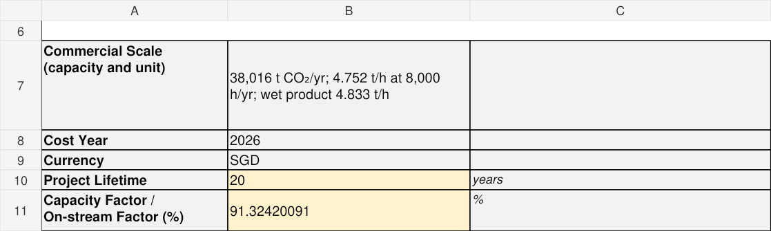
MEA_B | 6-Costs | A6:C11
Detailed costs are optional at TRL 4 and expected at TRL 5–6. Full-scale justified cost/performance targets in 3-Claims remain relevant in both templates. Do not add an unprovided AEDO capital-recovery factor.

Step B13 Enter capital accounts
6-Costs rows 15–22 contain eight named accounts. These views show the first four accounts and source columns. Enter numeric Cost Rate and Amount; preserve column G rate × amount formulas and the subtotal.
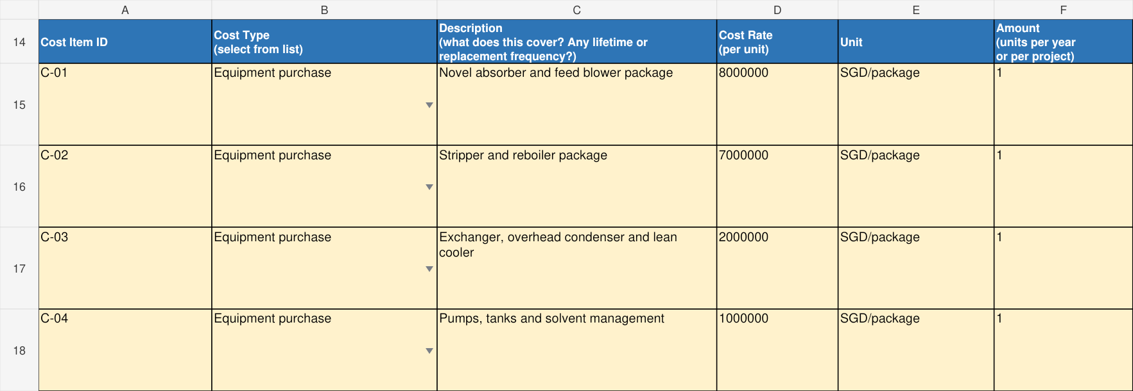
MEA_B | 6-Costs | A14:F18
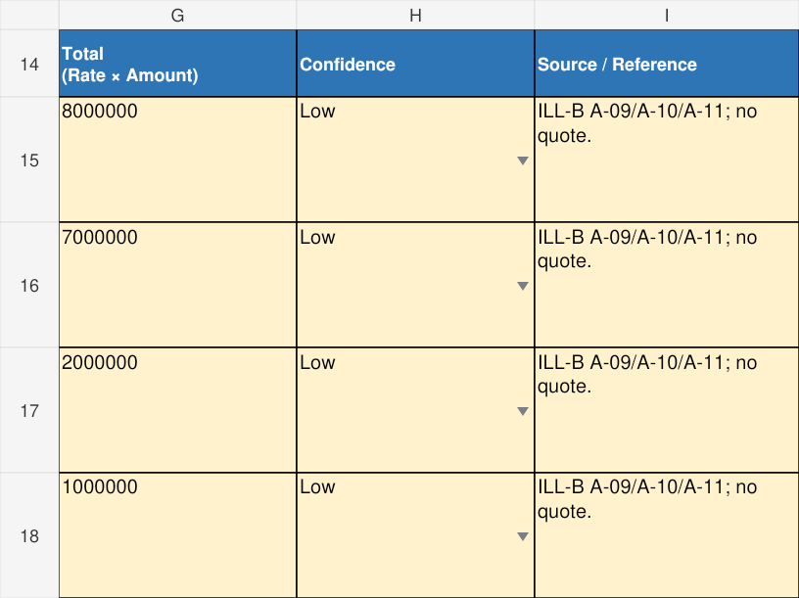
MEA_B | 6-Costs | G14:I18
MEA_B | 6-Costs | B33:G33
Total illustrative CAPEX is 30,000,000 SGD. The 8,000,000 SGD absorber/blower account aligns with the narrower Template A equipment-only target, while the complete integrated scope is broader.

Step B14 Enter annual operating costs
Use annual Amounts for consumables and utility records. The two excerpts show the six variable records and their source notes. Steam and waste-disposal Cost Type cells remain blank because the existing list has no exact category; the reason is recorded in the workbook.
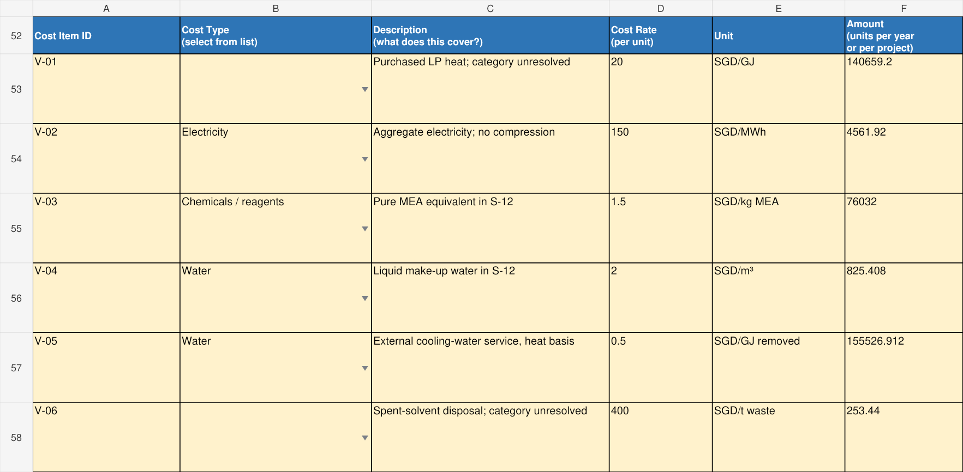
MEA_B | 6-Costs | A52:F58
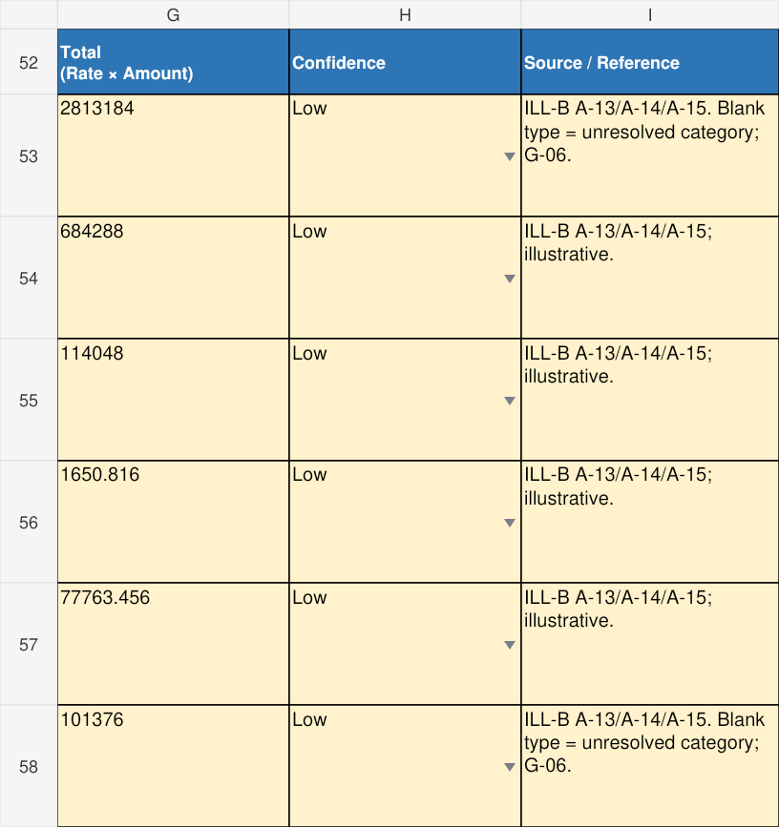
MEA_B | 6-Costs | G52:I58
MEA_B | 6-Costs | B65:G65
Variable cost is 3,792,310.272 SGD/yr. Fixed labour is 900,000 SGD/yr. Included cash OPEX is 4,692,310.272 ÷ 38,016 = 123.43 SGD/t captured. It excludes capital recovery and unpriced items and is neither a levelised capture cost nor an avoidance cost.

Step B15 Close the gaps register
7-DataGaps contains six records. These views show G-01 to G-03; the remaining records cover boundary/enthalpy verification, lifetime/cost validation and unresolved cost categories. Keep A-IDs and G-IDs consistent across sheets.
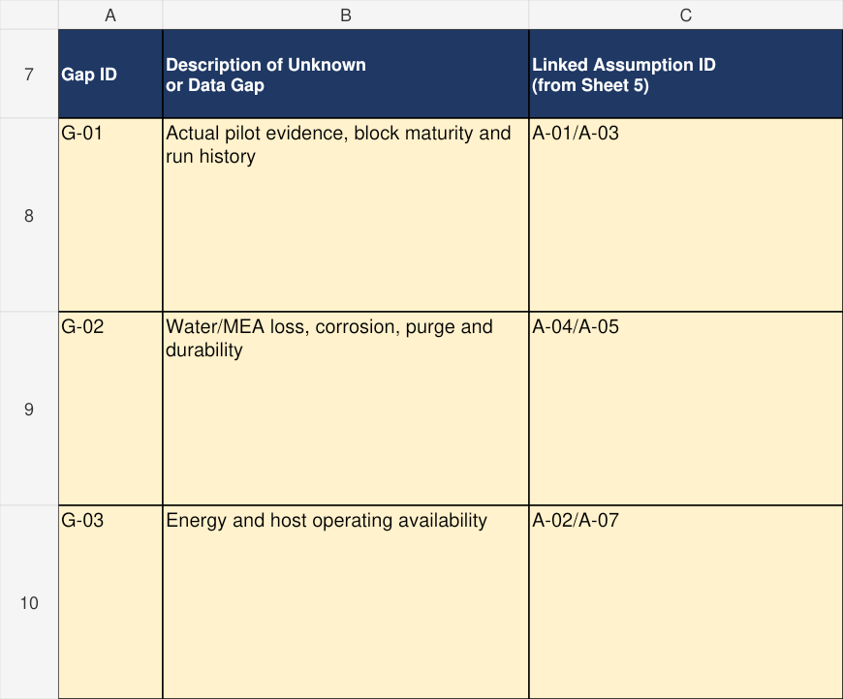
MEA_B | 7-DataGaps | A7:C10
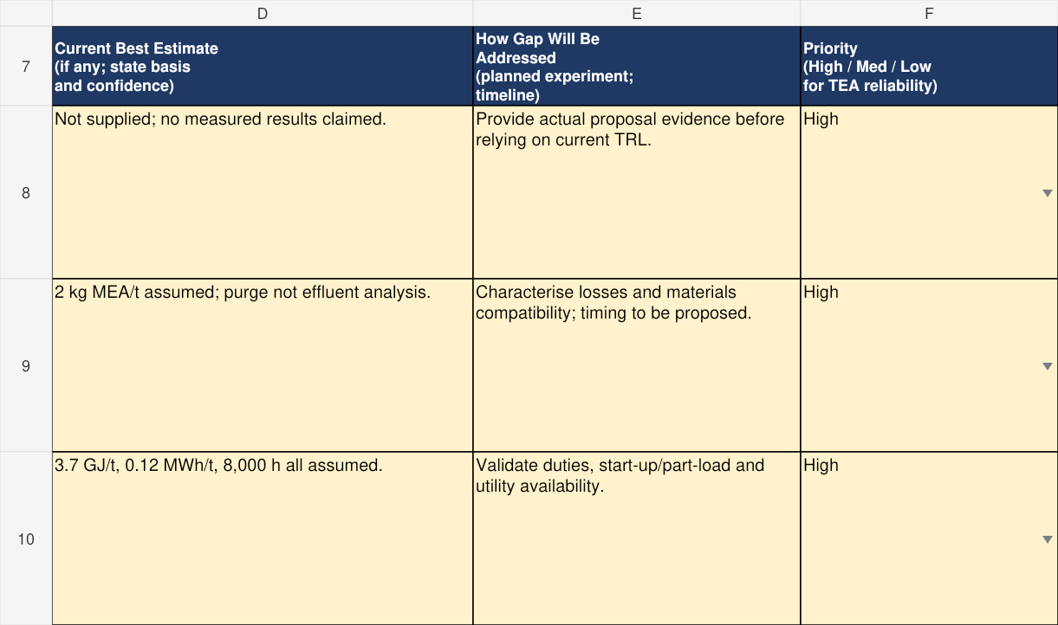
MEA_B | 7-DataGaps | D7:F10
A submission at TRL 5 requires project-specific evidence. Performance evidence, run counts, durations and dates must be supported by actual records.

Applying the templates to non process projects
Use the same final workbook selected by current TRL. A non-process technology still has a boundary, inputs, outputs, operating assumptions, evidence and cost drivers. Represent the relevant functional blocks, such as modules, power conversion and connection; chemical unit operations need only be included where applicable. Keep physical streams separate from performance metrics and counterfactual emissions claims.
The solar example concerns a hypothetical novel lightweight module at current TRL 4, projected to a 100 kWp rooftop installation. This maturity assumption is about the novel module; it does not imply conventional PV is low TRL. No actual laboratory evidence or installation is claimed. The missing evidence is G-01.
Process-style field | Solar interpretation
1-Diagram blocks | PV modules; inverter and balance of system; auxiliary/monitoring system
2-StreamTable streams | Sunlight, internal DC, gross AC, grid auxiliary input and loss-energy streams
Material properties and 4-Balance 4A | Not applicable to the electricity-conversion boundary, with explanation; not a fabricated zero-mass process
3-Claims | Module efficiency, projected net annual generation, CAPEX, degradation target and operational avoided emissions
5-Assumptions | Capacity, aperture area, irradiance/yield factors, losses, auxiliary demand, economic inputs and carbon counterfactual
6-Costs and 7-DataGaps | Installed array scope, annual operating inputs, module evidence, site yield/baseline and roof/durability/cost uncertainties

For a comparable current TRL 1–3 project, use Template A: put these functional blocks in 1-Diagram, relevant boundary-energy entries in 2-StreamsEnergy, performance/cost targets in 3-Claims, and real unknowns in 4-DataGaps. Do not add Template B sheets or force phase/composition into Template A.

Solar PV Worked Example for TRL 4–6
Step S1 Define capacity and the boundary
The populated solar workbook uses 250 panels × 400 Wp = 100 kWp. Each panel has 2 m² aperture, giving 500 m² module aperture. This is not the roof footprint. The embedded diagram matches all seven streams in 2-StreamTable.
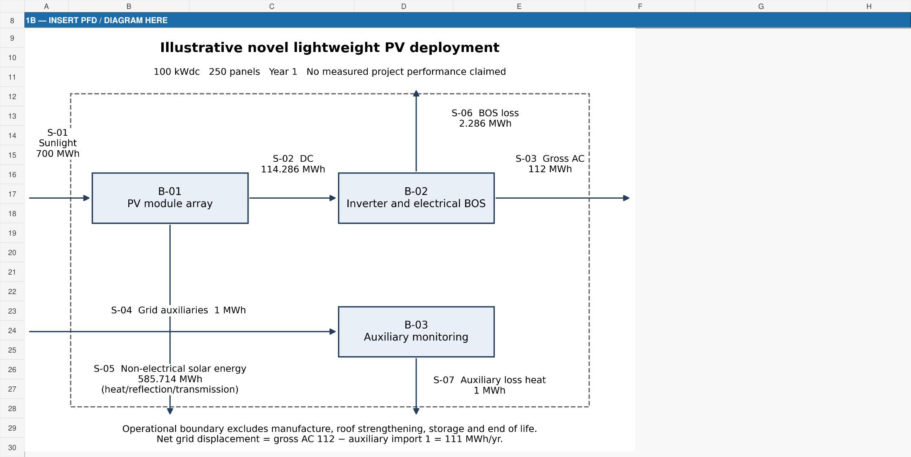
SOLAR | 1-Diagram | A8:H30

Step S2 Enter functional blocks
Use the existing block table for the three functional subsystems. Select Other — specify in notes, explaining variable sunlight-driven operation and annual averages in the notes and 3-Claims. Do not describe PV as operating at nameplate power all year.
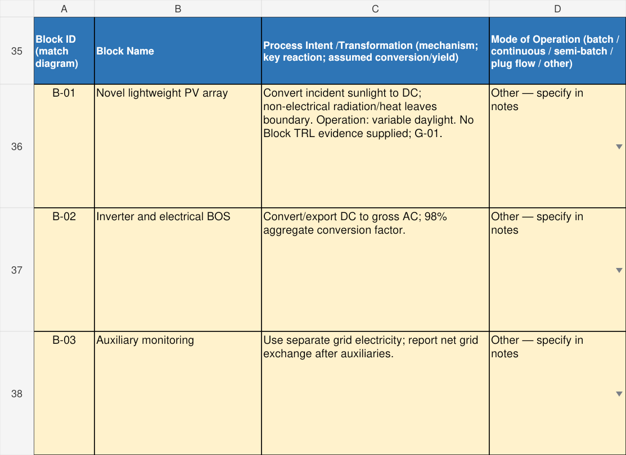
SOLAR | 1-Diagram | A35:D38
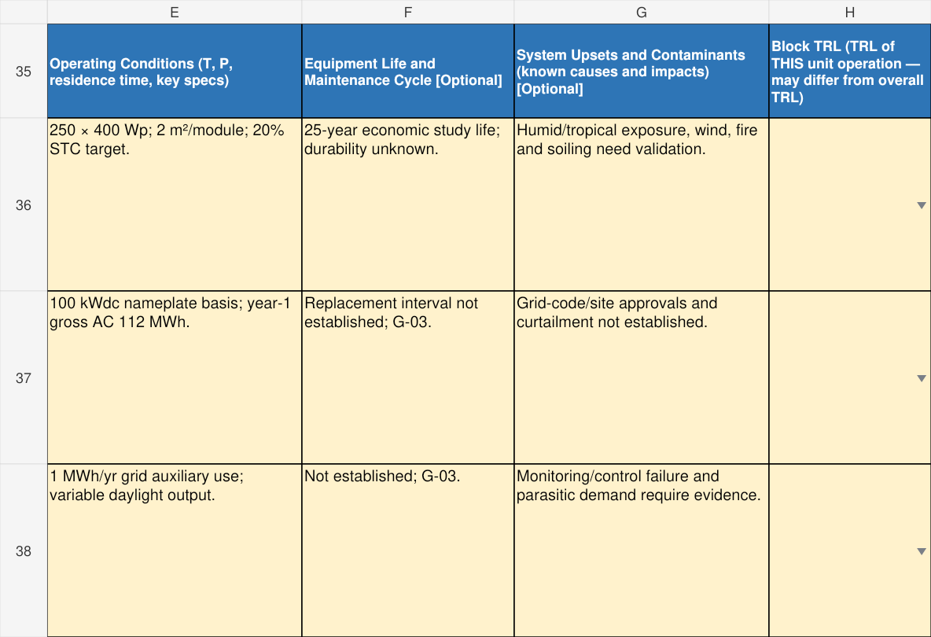
SOLAR | 1-Diagram | E35:H38
Installation context, roof loading, wind, electrical isolation, inverter protection, end-of-life handling and module durability require project-specific evidence. The example supplies no certification or approved design.

Step S3 Enter energy stream identities
The native matrix shows S-01 sunlight, S-02 internal DC and S-03 gross AC. Phase, temperature and pressure are marked Not applicable for these energy-only streams; Total Mass Flow remains blank. Source / Reference explains the entry basis.
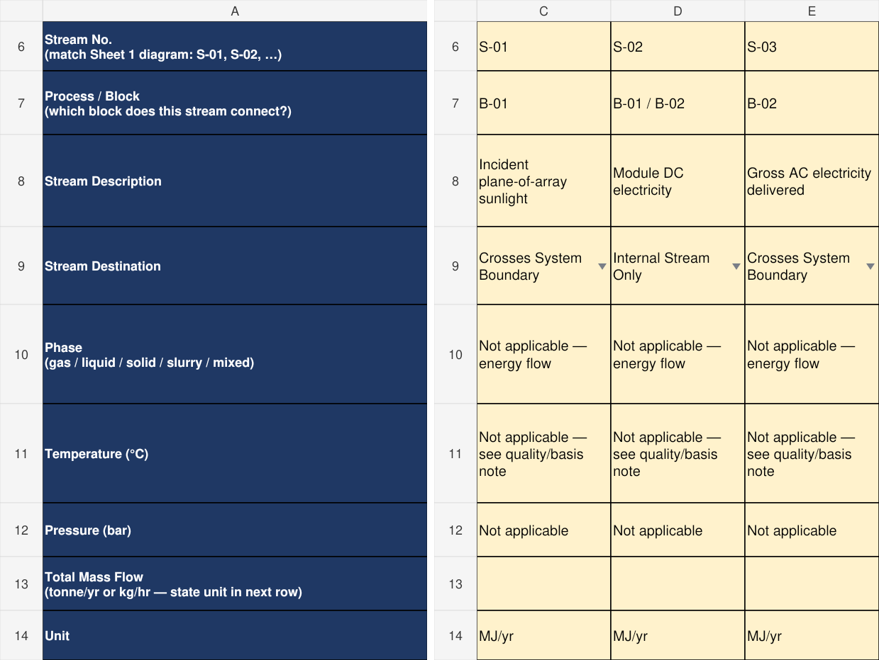
SOLAR | 2-StreamTable | A6:A14 plus C6:E14
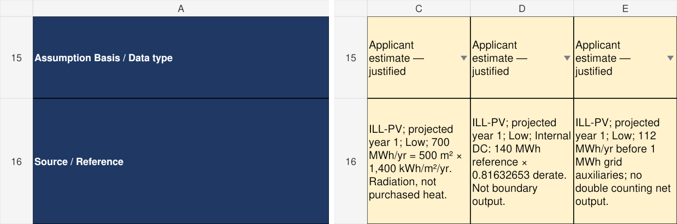
SOLAR | 2-StreamTable | A15:A16 plus C15:E16
Do not enter irradiance in W/m² as if it were annual electricity. The example uses annual plane-of-array irradiation of 1,400 kWh/m²/yr, an illustrative assumption, not a measured weather dataset or a Singapore benchmark.

Step S4 Map solar energy into existing rows
These native excerpts show the existing energy rows for sunlight, internal DC and gross AC, followed by auxiliary demand and losses. Incident radiation is mapped to the available thermal-energy row as a documented entry assumption, with an explicit radiation label. It is not purchased process heat.
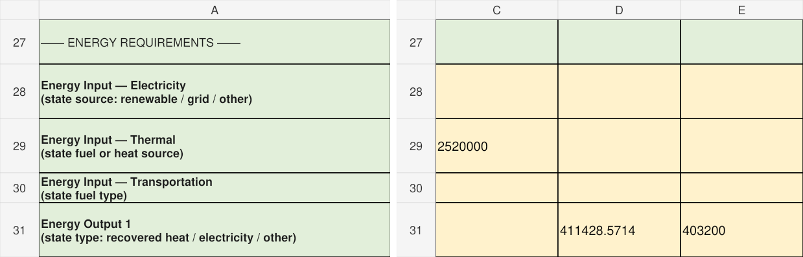
SOLAR | 2-StreamTable | A27:A31 plus C27:E31
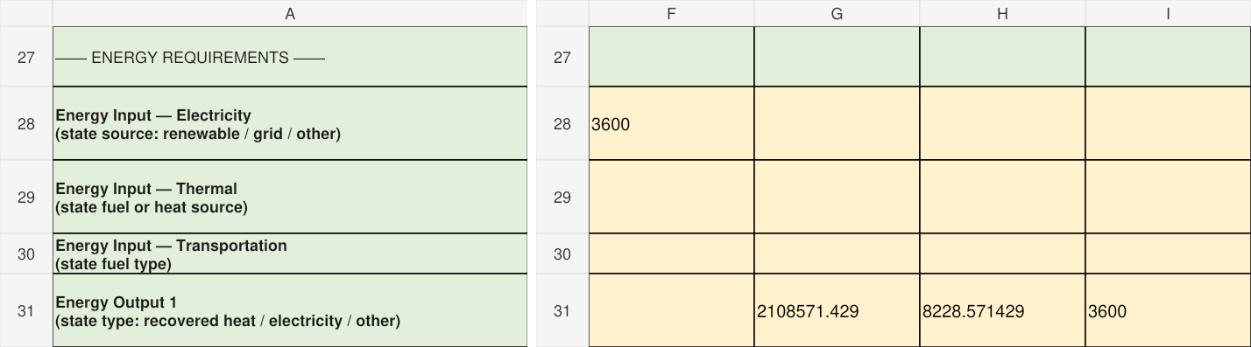
SOLAR | 2-StreamTable | A27:A31 plus F27:I31
Use MJ/yr consistently: 1 MWh = 3,600 MJ. S-02 remains internal. Non-electrical solar energy includes reflection/transmission and heat; it is not useful exported heat.

Step S5 Calculate yield without double counting
Start with 500 m² × 1,400 kWh/m²/yr = 700,000 kWh/yr = 700 MWh/yr incident sunlight. A 20% STC module-efficiency target gives a 140 MWh/yr reference DC yield. Apply the explicitly assumed DC derating factor 0.81632653 to obtain 114.285714 MWh/yr actual DC. Apply the downstream balance-of-system factor 0.98 to obtain 112 MWh/yr gross AC. Together, these factors give performance ratio 0.80.
Subtract 1 MWh/yr imported auxiliary electricity once: 112 − 1 = 111 MWh/yr net grid displacement. Do not subtract auxiliary demand again inside the 0.80 factor, and do not call 111 MWh the gross inverter output. The 12.7854% value in Capacity Factor is 112 MWh ÷ (0.1 MWdc × 8,760 h); it is a DC-nameplate equivalent, not daylight availability.
Energy stream | MWh per year | Boundary treatment
S-01 Incident sunlight | 700 | Input
S-02 DC electricity | 114.285714 | Internal only
S-03 Gross AC electricity | 112 | Output
S-04 Grid auxiliary electricity | 1 | Input
S-05 Non-electrical solar energy | 585.714286 | Output
S-06 Inverter and BOS losses | 2.285714 | Output
S-07 Auxiliary dissipation | 1 | Output

Gross inputs = 701 MWh/yr; gross outputs = 112 + 585.714286 + 2.285714 + 1 = 701 MWh/yr. Losses are allocated by difference for teaching closure, not independently measured. Detailed optical, thermal and electrical modelling remains a gap.

Step S5 Record claims and carbon context
3-Claims contains six records. The first two below separate STC efficiency and annual net generation. The other records cover CAPEX, degradation, operational avoided emissions and missing actual module evidence.
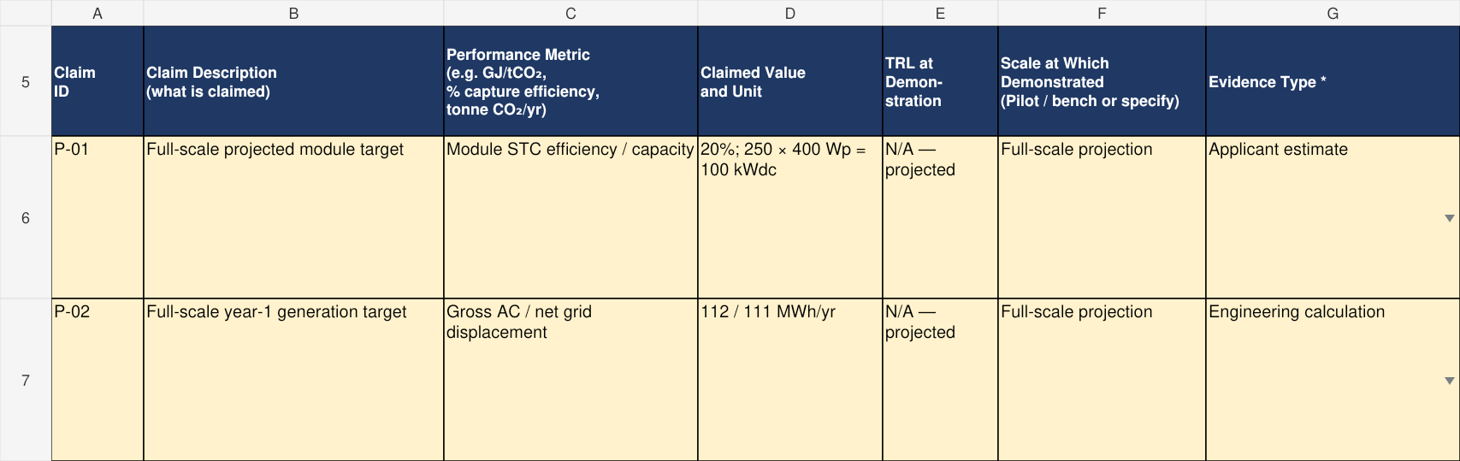
SOLAR | 3-Claims | A5:G7
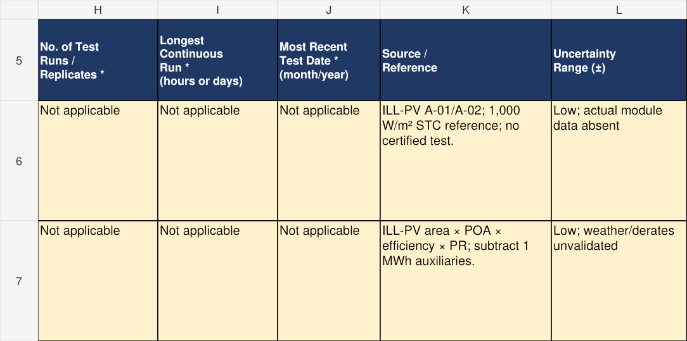
SOLAR | 3-Claims | H5:L7
STC 20% efficiency is a module test-condition target. Annual yield includes system losses and resource variability; it is not equivalent to STC efficiency. Degradation 0.5%/yr and project lifetime 25 years are illustrative assumptions, not a warranty.

Step S6 Keep avoided emissions separate
The operational counterfactual is explicitly illustrative: net grid displacement 111 MWh/yr × assumed grid factor 0.4 tCO₂e/MWh = 44.4 tCO₂e/yr. The factor is not an official Singapore emissions factor. Replace it with a defensible site/year baseline and state whether grid imports, exports, temporal matching and any curtailment affect the calculation.
Record this result in 3-Claims P-05, its evidence/source notes and 5-Assumptions. Do not enter 44.4 tCO₂e as a physical CO₂ output or as a negative material stream. Operational avoided emissions exclude embodied manufacturing, replacements and end-of-life; no lifecycle neutrality claim follows.
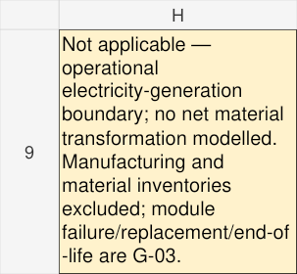
SOLAR | 4-Balance | H9:H9
4-Balance material/carbon is explained as Not applicable to this operational electricity-conversion boundary. Blank entries and zero totals/dashes from inherited formulas are not proof that manufacturing or lifecycle material/carbon impacts are zero. A broader manufacturing/storage boundary would require its relevant material and carbon entries.

Step S7 Reconcile the annual energy balance
Use the boundary streams in 4-Balance section 4B. The left view shows annual MJ inputs/outputs; the right view supplies source and allocation notes. S-02 internal DC is excluded from the boundary totals.
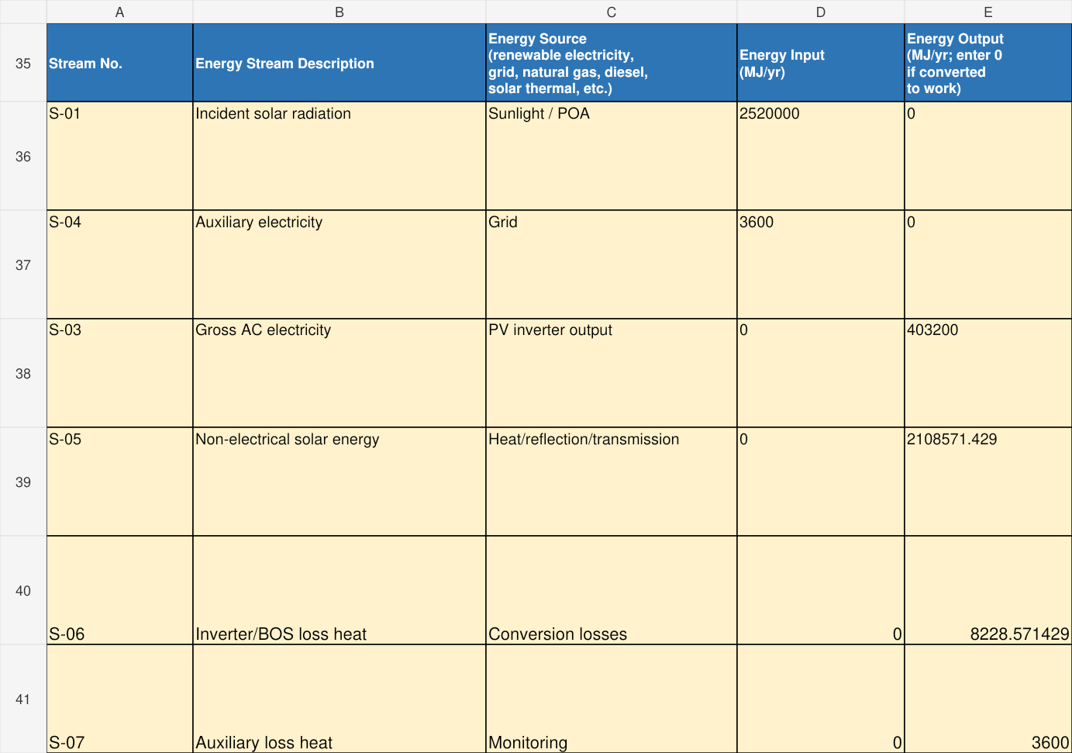
SOLAR | 4-Balance | A35:E41
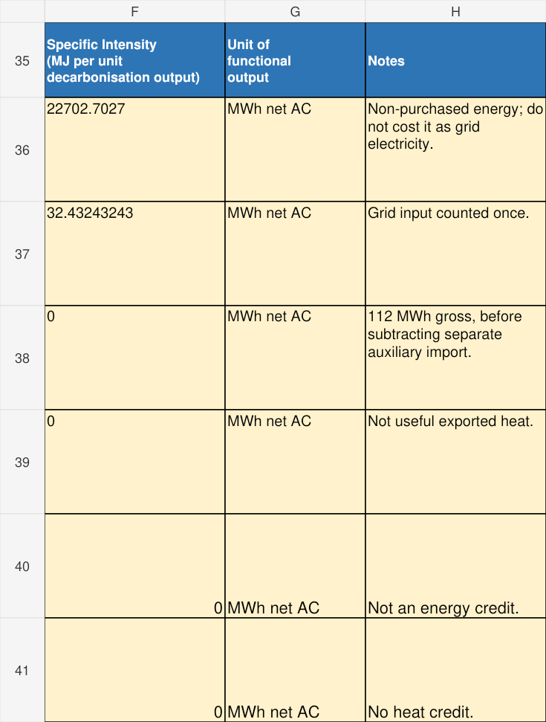
SOLAR | 4-Balance | F35:H41
Total input/output = 2,523,600 MJ/yr. Specific Energy Intensity is gross incident-plus-auxiliary energy ÷ net AC = 22,735.135 MJ/MWh net. Its stated solar-inclusive basis is not purchased-energy intensity, LCOE or a system-efficiency percentage.

Step S8 Document the assumptions
5-Assumptions contains ten linked records. These native excerpts show the first four. Irradiation, DC/BOS factors, auxiliary demand, degradation, economics and the carbon counterfactual remain labelled as teaching assumptions.
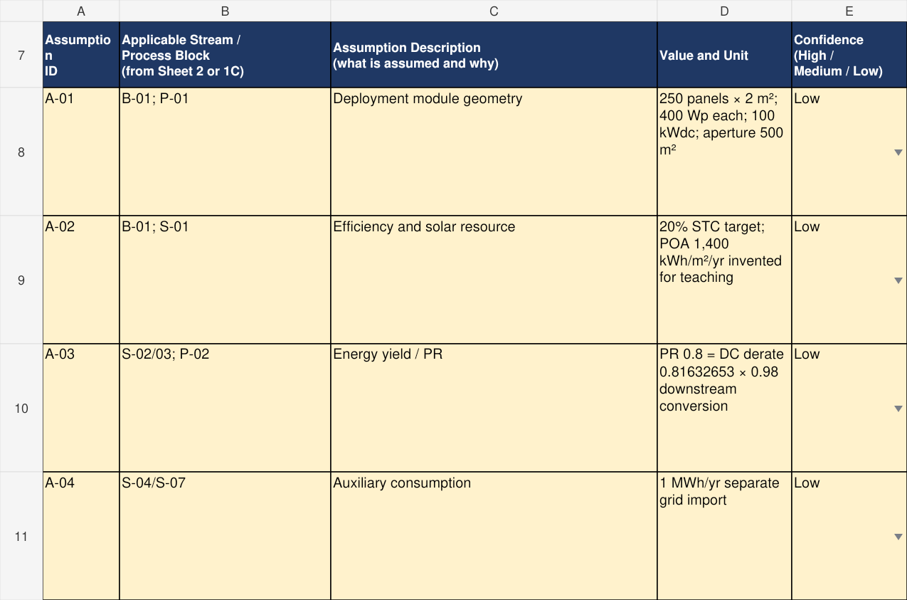
SOLAR | 5-Assumptions | A7:E11
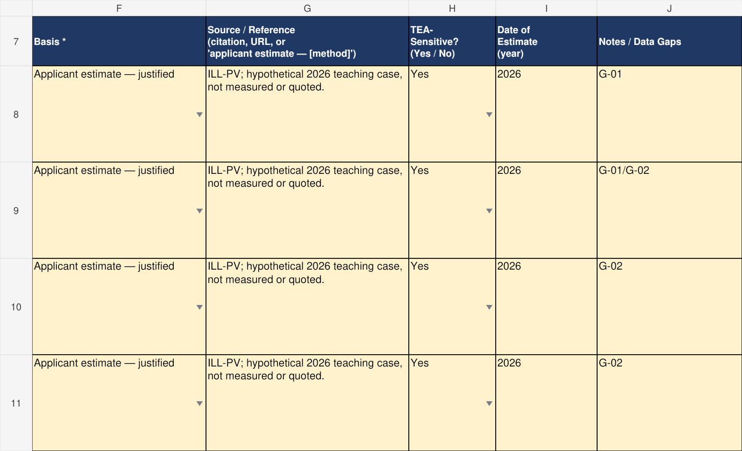
SOLAR | 5-Assumptions | F7:J11
For a real project provide a site-specific yield study, shading and availability basis, actual module evidence, roof/site constraints and quotations. If actual information is unavailable, record the evidence gap and the information needed to address it.

Step S9 Enter solar capital costs
Use the existing 6-Costs structure. Five installed-scope accounts total 150,000 SGD: panels 70,000; inverter 20,000; mounting 30,000; installation 20,000; engineering 10,000. These are illustrative costs, not market quotations.
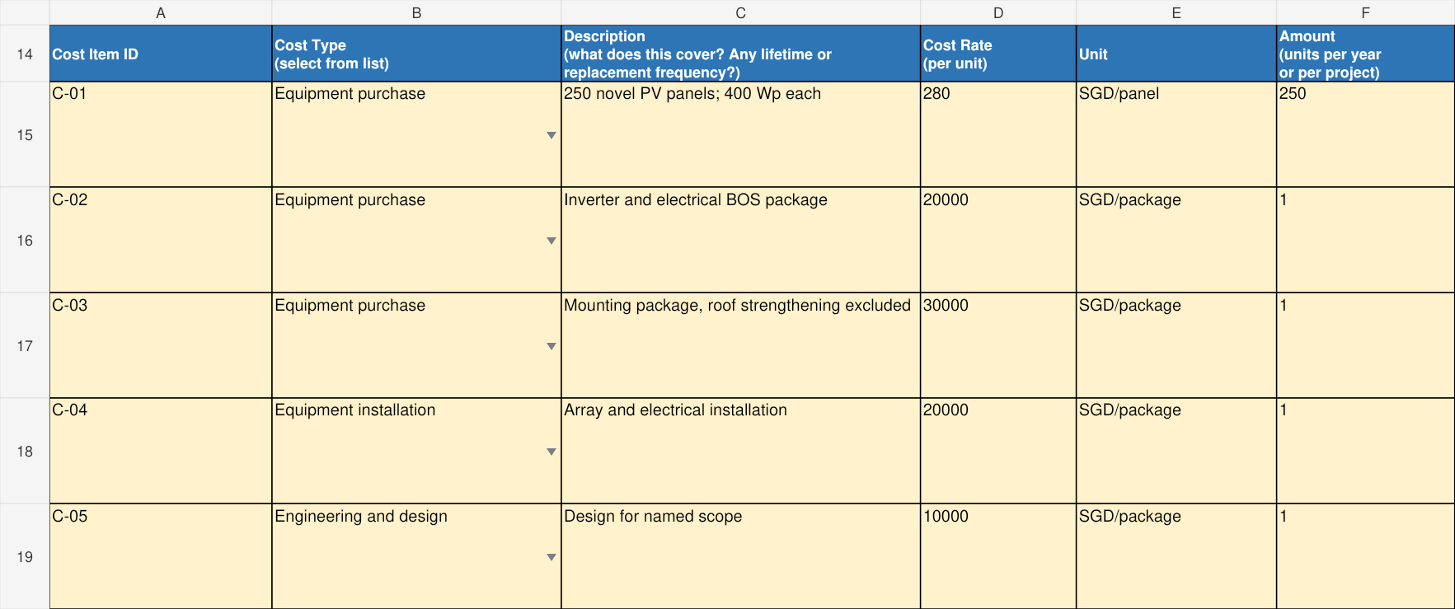
SOLAR | 6-Costs | A14:F19
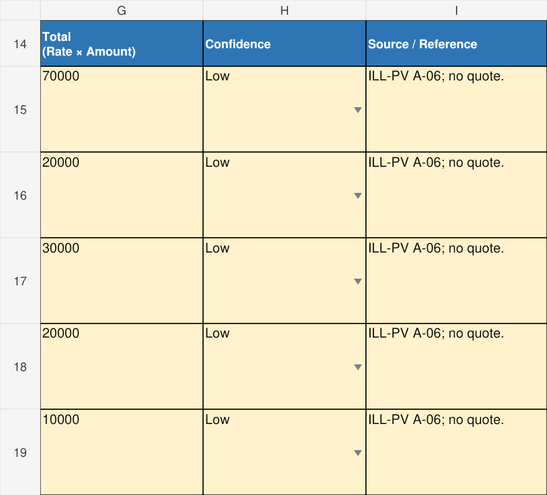
SOLAR | 6-Costs | G14:I19
SOLAR | 6-Costs | B33:G33

Step S10 Enter annual operating inputs
Annual costs are 2,000 SGD labour, 150 SGD auxiliary grid electricity and 20 SGD water, giving included cash OPEX 2,170 SGD/yr. Do not infer a complete project estimate from these selected accounts; roof works, replacement scope and disposal require project evidence.
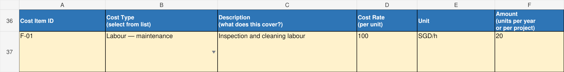
SOLAR | 6-Costs | A36:F37
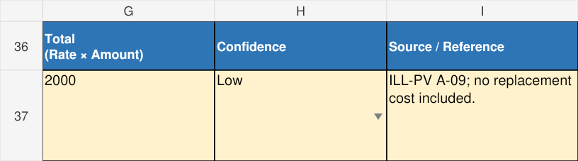
SOLAR | 6-Costs | G36:I37
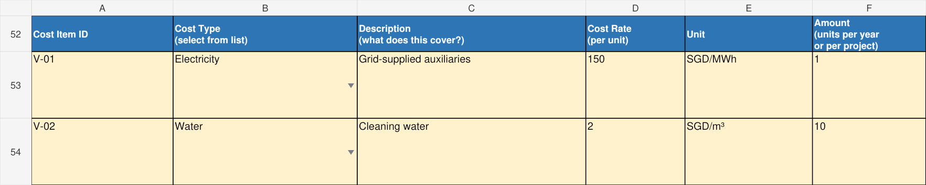
SOLAR | 6-Costs | A52:F54
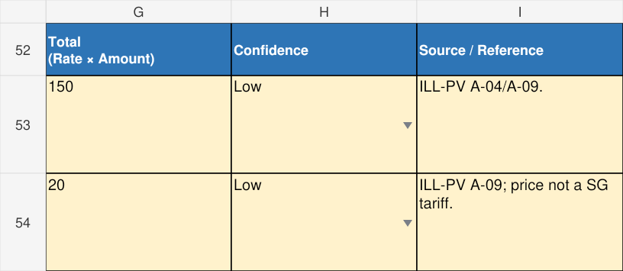
SOLAR | 6-Costs | G52:I54

Step S11 Record solar gaps
7-DataGaps includes three actual records for current module evidence, site yield/grid baseline, and roof/durability/cost scope. The two views complete the same three rows. Link them to the assumptions and projected claims.
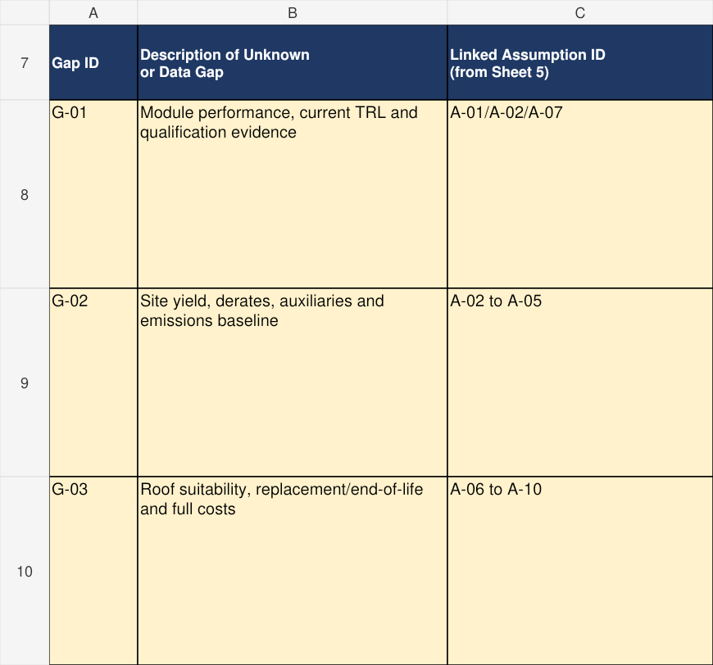
SOLAR | 7-DataGaps | A7:C10
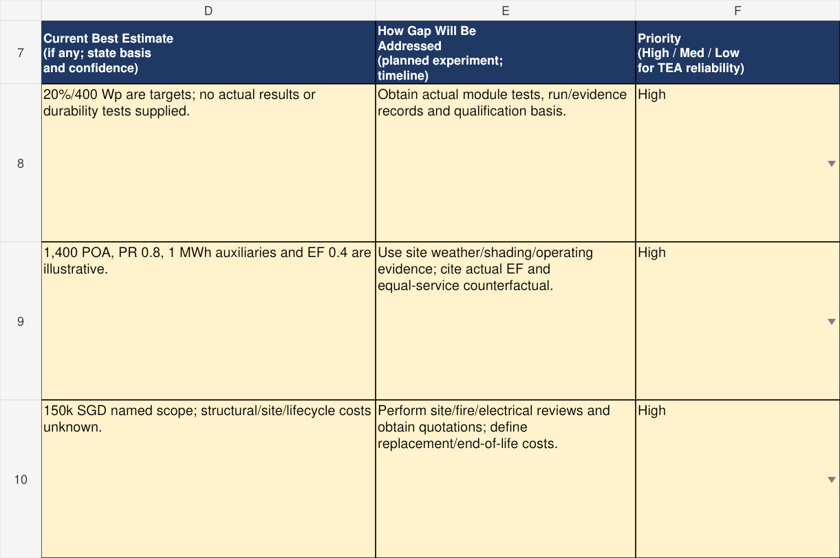
SOLAR | 7-DataGaps | D7:F10
Before submission, replace the hypothetical TRL 4 premise with an evidenced current-TRL assessment. The completed example documents assumptions and evidence gaps; it does not establish that the novel product has been tested.

Checks and common errors before submission
Check | How to verify
Workbook and maturity | Use current TRL; do not use end-of-project TRL or infer system maturity from commercial components.
Boundary and diagrams | Use the exact 1-Diagram entry location. Verify every B-ID, every relevant S-ID and all included/excluded utility interfaces. Confirm a legible PNG/JPG at minimum 150 dpi and A4 print readability.
Evidence and projections | Use actual sources and test history; label deployment projections. Replace illustrative codes ILL-A, ILL-B and ILL-PV with project evidence.
Inputs and units | Numeric values are numeric. Scale, operating basis, components and units are consistent across sheets. Convert MWh to MJ using ×3,600.
Material balance | Exclude internal recycles. Separate constituent masses when using dry carbon fractions with wet streams. Include carbon in solvent and reagents where relevant.
Energy intensity | State denominator and boundary. Do not confuse heat duty with electricity, subtract internal heat recovery twice, or call gross input “net”.
Costs | Use consistent year/currency; distinguish annual quantities from one-time packages. Preserve rate × amount formulas. Identify omitted costs and unresolved categories; zero totals do not prove completeness.
Assumptions and gaps | Meet retained minimum counts with genuine items or explain the shortfall for AEDO clarification. Link A-IDs and G-IDs.
Final completeness | Cover and declaration addressed; primary claims and full-scale cost/performance targets included; guide instructions checked against final labels.

Appendix A — MEA Worked Example for TRL 1–3
Workbook: MEA Example TRL 1to3.xlsx
An analytical MEA absorber concept at current TRL 2, with an absorber-only boundary, BFD, stream and energy entries, claims and data gaps.
All example values and project maturity premises are illustrative; the evidence limitations described in the main guide also apply to this appendix.
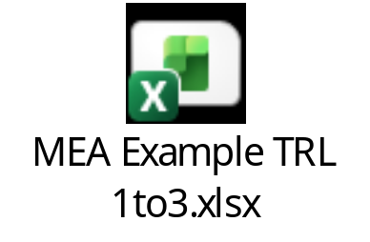
Click here to return back to worked example

Appendix B — MEA Worked Example for TRL 4–6
Workbook: MEA Example TRL 4to6.xlsx
A hypothetical current TRL 5 MEA absorber project with deployment-scale projections, an integrated capture-island PFD, stream data, balances, assumptions, costs and data gaps.
All example values and project maturity premises are illustrative; the evidence limitations described in the main guide also apply to this appendix.
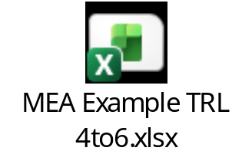

Click here to return back to worked example

Appendix C — Solar PV Worked Example for TRL 4–6
Workbook: Solar PV Example TRL 4to6.xlsx
A hypothetical current TRL 4 lightweight PV module project projected to a 100 kWp rooftop installation, with a system diagram, energy flows, performance claims, assumptions, costs and data gaps.
All example values and project maturity premises are illustrative; the evidence limitations described in the main guide also apply to this appendix.
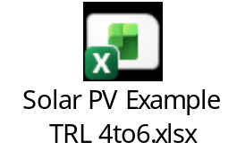

Click here to return back to worked example

